# **Snowflake**

Create a free account. I used the bendix email. Jsl._ _ _ _ select Amazon as storage.

Create a new DB and a new table with 2 columns:

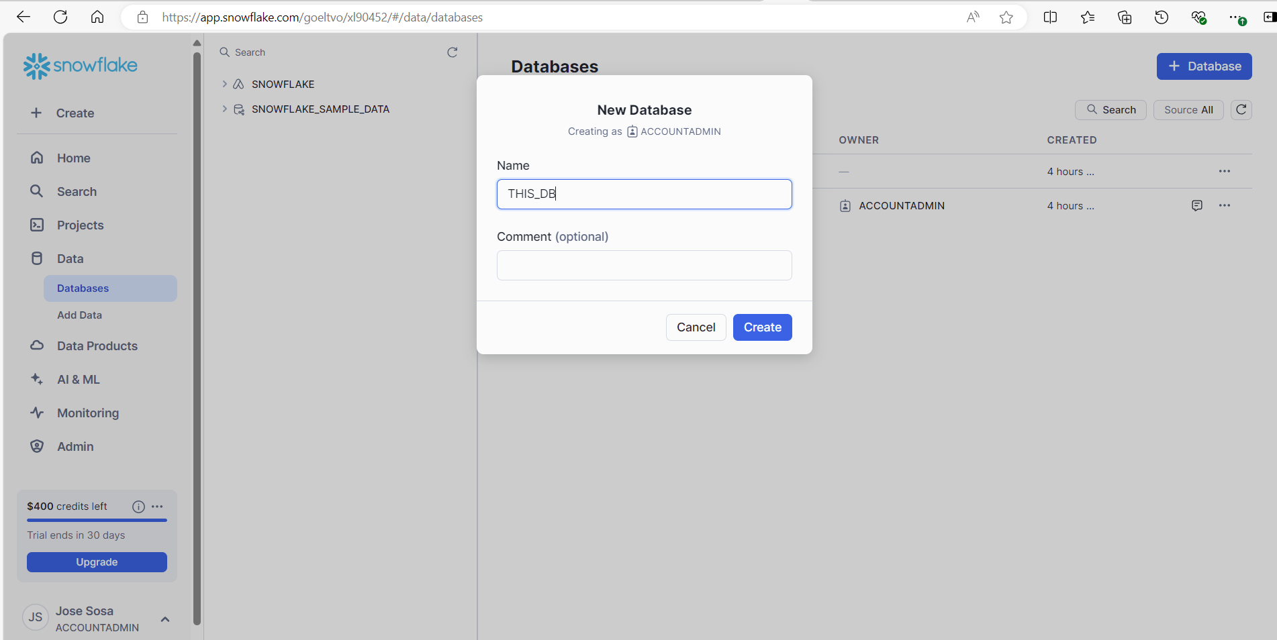  
Create → Table → Standard

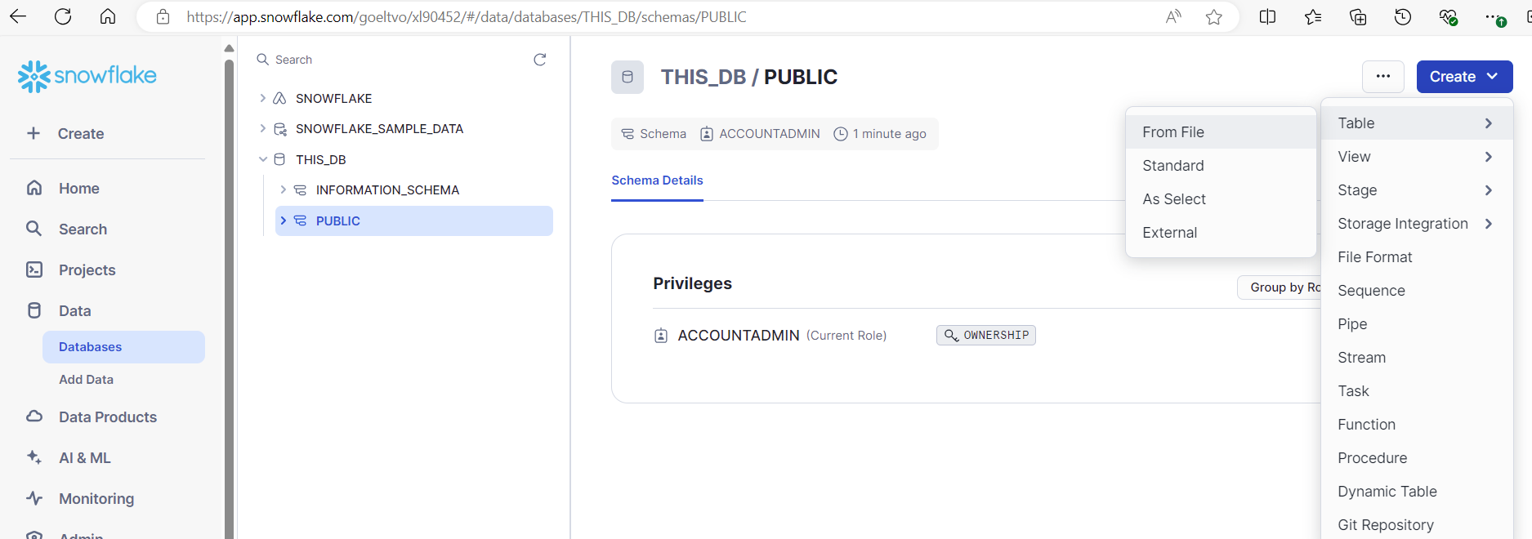

Replace:

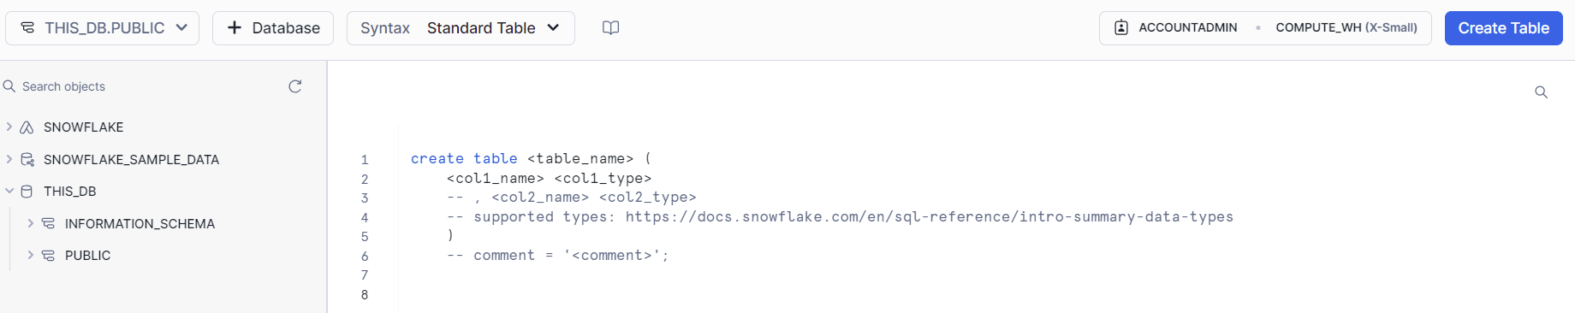

By:

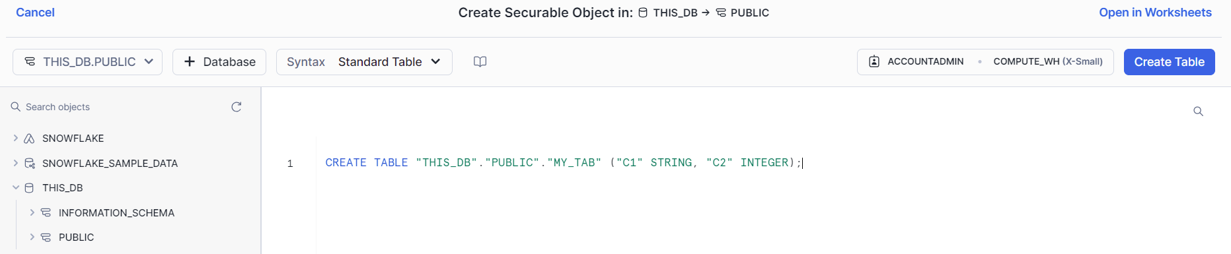

Or:

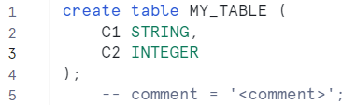

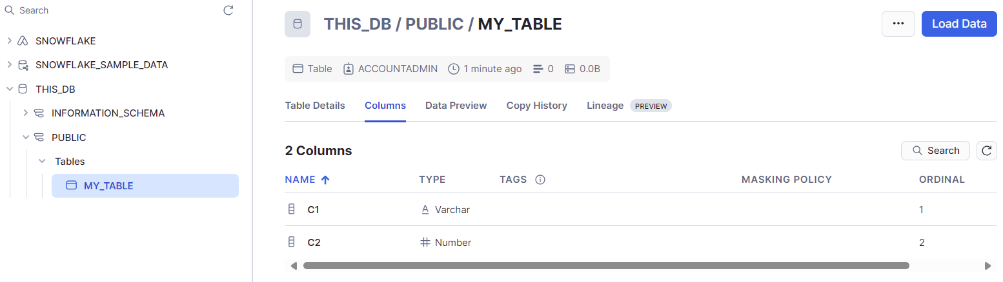

If I want to do a query I can open in Worksheets: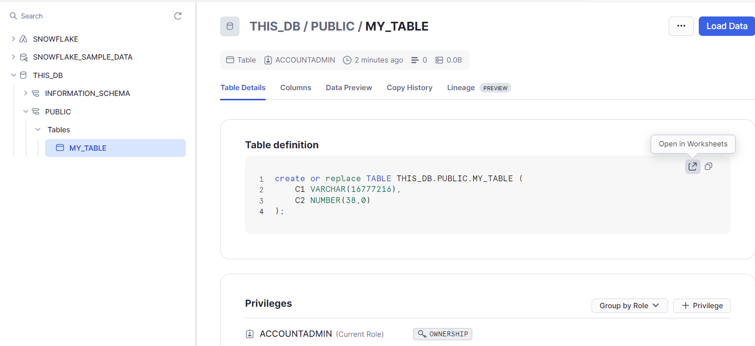

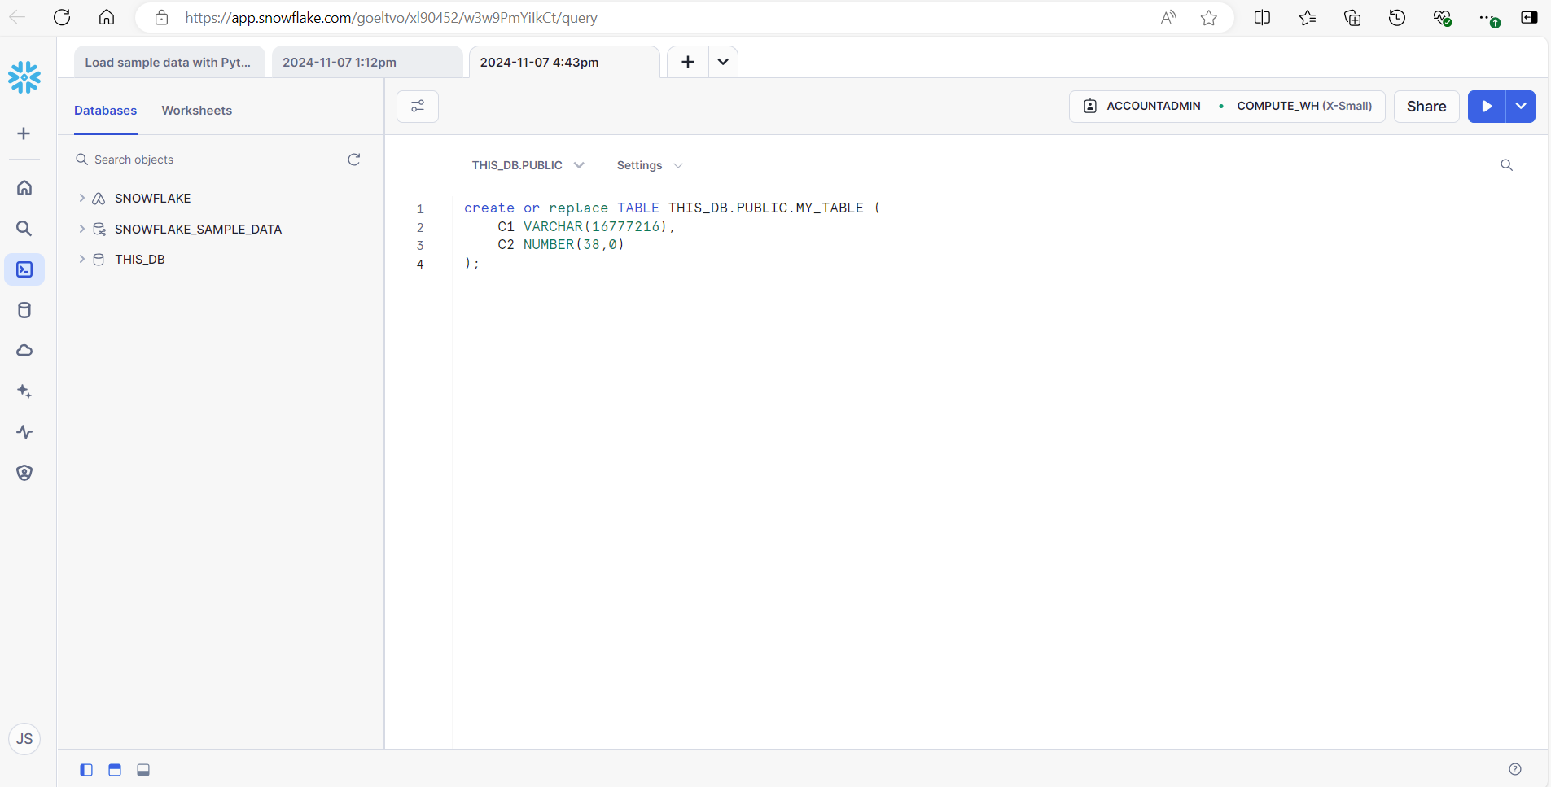

Review documentation:  
[Tutorial: Bulk loading from a local file system using COPY | Snowflake Documentation](https://docs.snowflake.com/user-guide/tutorials/data-load-internal-tutorial)

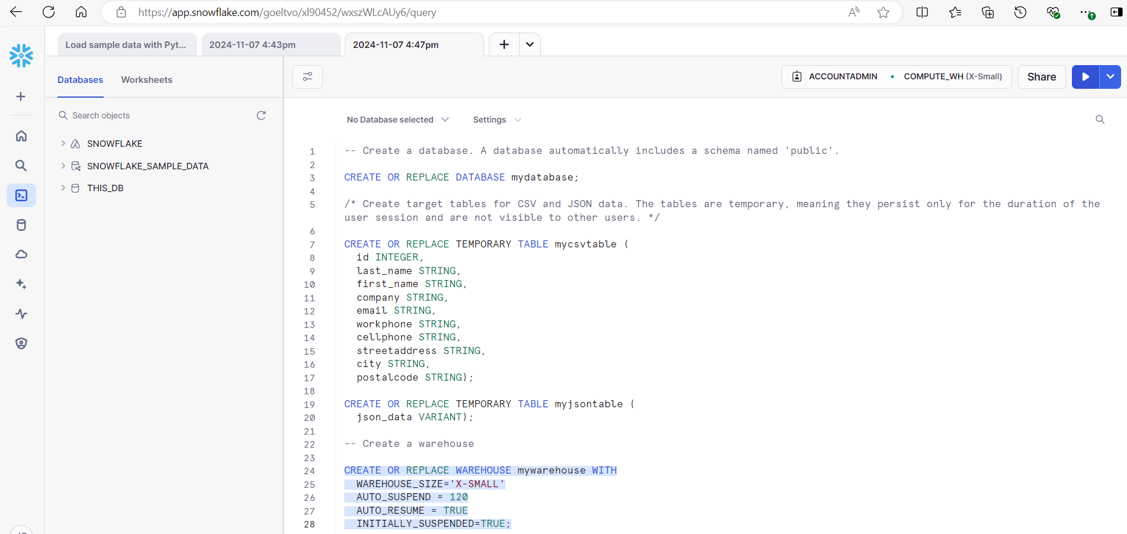

When I ran this, it took maybe a few seconds, i continue and after few seconds I was able to see the database.

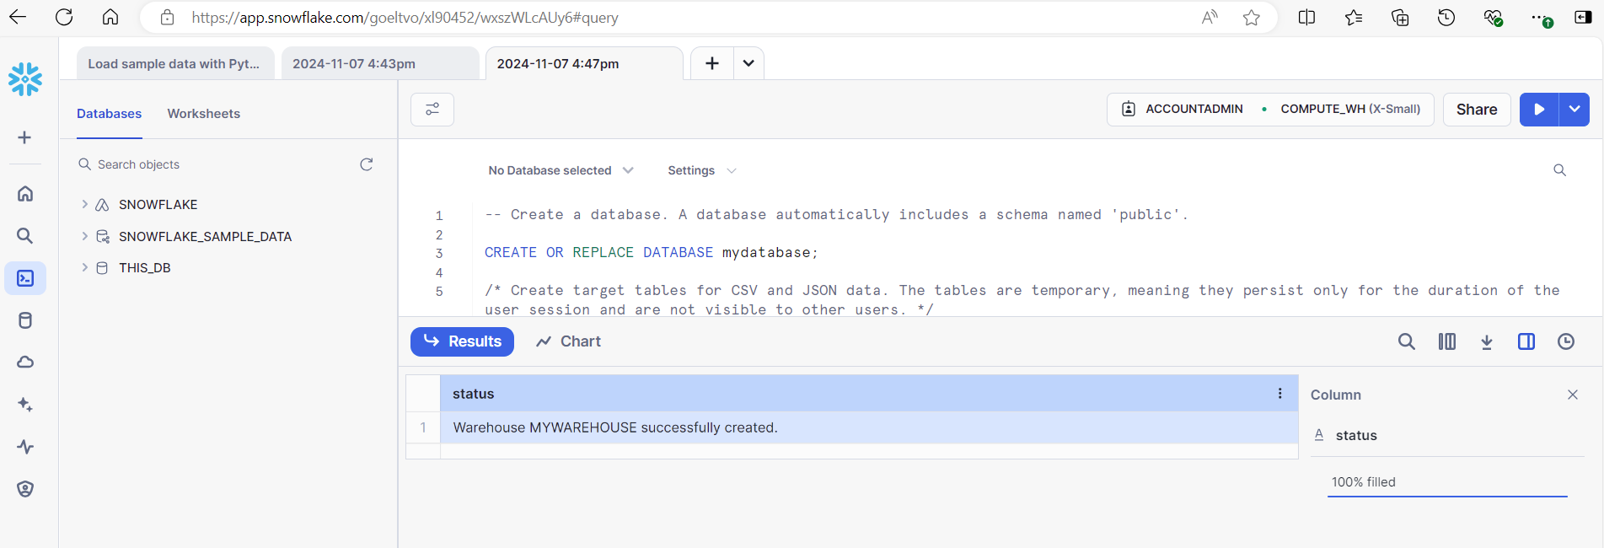

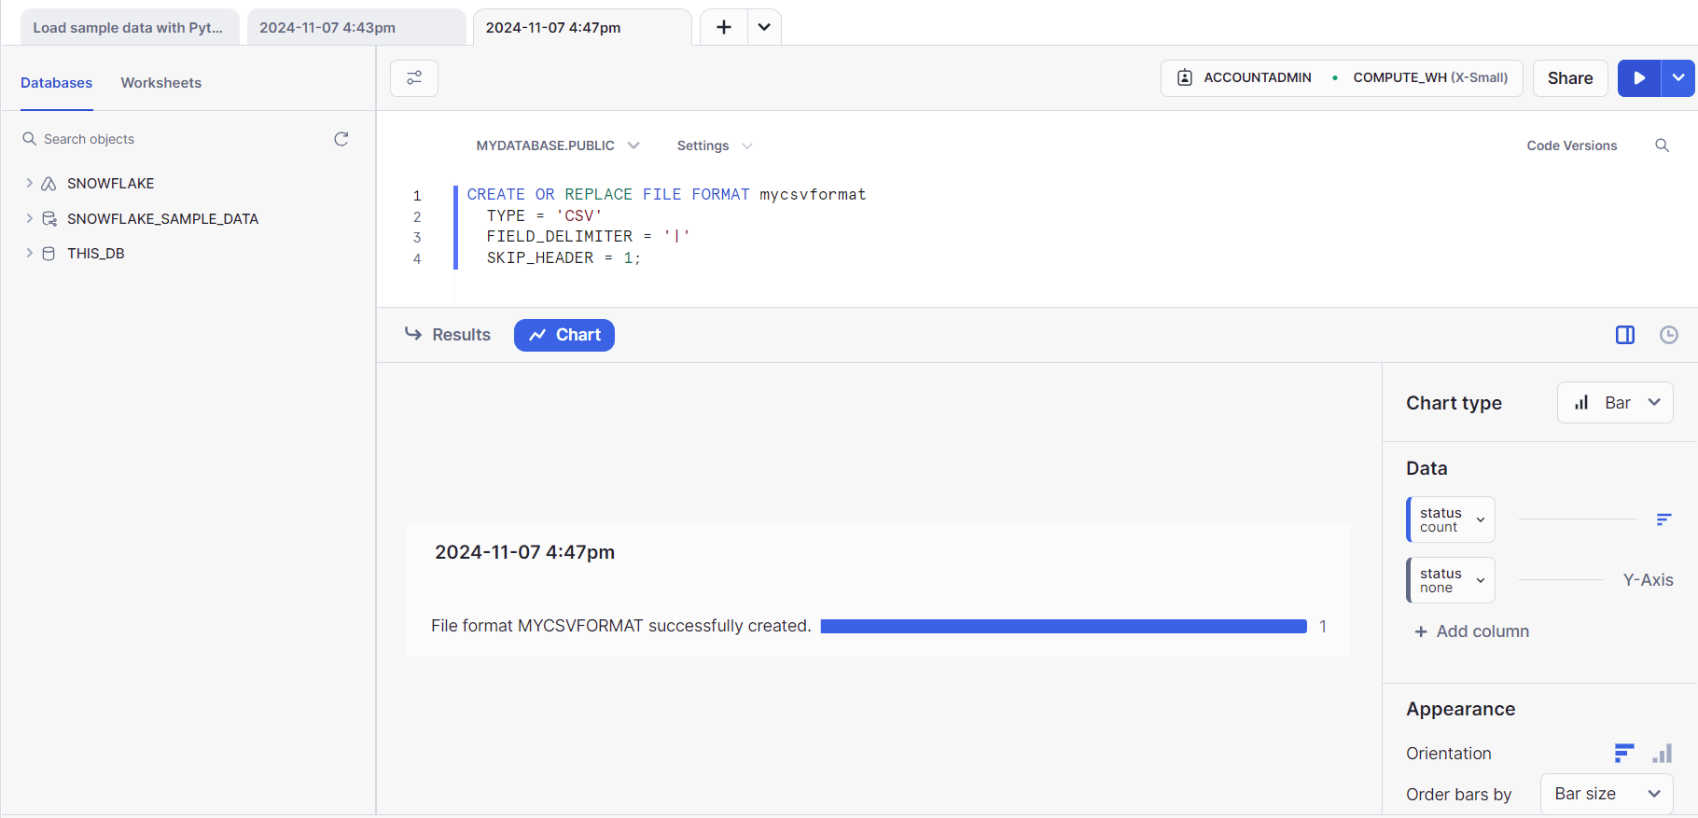

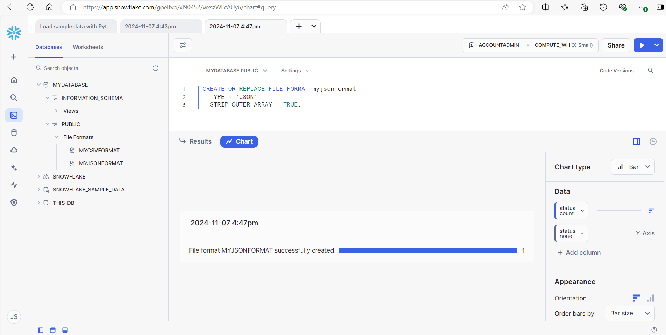

CREATE OR REPLACE DATABASE mydatabase;

CREATE OR REPLACE TEMPORARY TABLE mycsvtable (

id INTEGER,

last_name STRING,

first_name STRING,

company STRING,

email STRING,

workphone STRING,

cellphone STRING,

streetaddress STRING,

city STRING,

postalcode STRING);

CREATE OR REPLACE TEMPORARY TABLE myjsontable (

json_data VARIANT);

CREATE OR REPLACE WAREHOUSE mywarehouse WITH

WAREHOUSE_SIZE='X-SMALL'

AUTO_SUSPEND = 120

AUTO_RESUME = TRUE

INITIALLY_SUSPENDED=TRUE;

**Creacion de objetos de escenario:**

Creación de una etapa para archivos de datos CSV:

Ejecute CREATE STAGE para crear la etapa:my_csv_stage

CREATE OR REPLACE STAGE my_csv_stage

FILE_FORMAT = mycsvformat;

Tenga en cuenta que si especifica la opción al crear la etapa, no es necesario especificar la misma opción en el comando COPY utilizado para cargar datos desde la etapa.FILE_FORMAT

Creación de una fase para archivos de datos JSON

Ejecute CREATE STAGE para crear la etapa:my_json_stage

CREATE OR REPLACE STAGE my_json_stage

FILE_FORMAT = myjsonformat;

Ejecute el comando PUT para cargar los archivos CSV desde su sistema de archivos local.

• Linux o macOS

• PUT file:///tmp/load/contacts*.csv @my_csv_stage AUTO_COMPRESS=TRUE;

• Windows

PUT file://C:\temp\load\contacts*.csv @my_csv_stage AUTO_COMPRESS=TRUE;

In my case I had the files in Documents\snowflake\data-load-internal, so I ran:

PUT file://C:\Users\20023350\Documents\snowflake\data-load-internal\contacts*.csv @my_csv_stage AUTO_COMPRESS=TRUE;

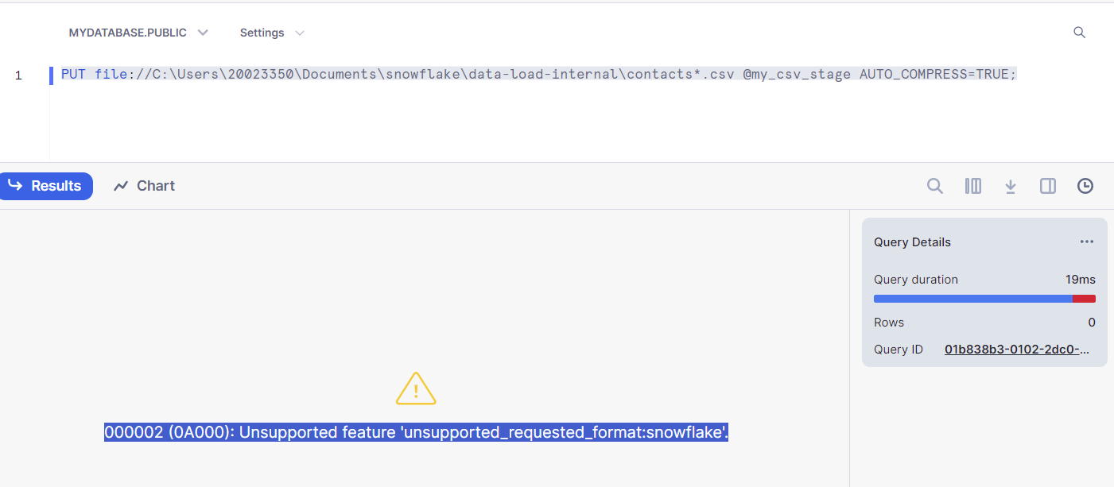

It was failing since the command cannot be executed from the Worksheets it should be executed with snowSQL, so it needs to have installed snowSQL CLI

[Installing Snowflake CLI | Snowflake Documentation](https://docs.snowflake.com/en/developer-guide/snowflake-cli/installation/installation)

(tal vez tambien sea el mismo que si lo hago con pip? pip install snowflake-cli-labs)

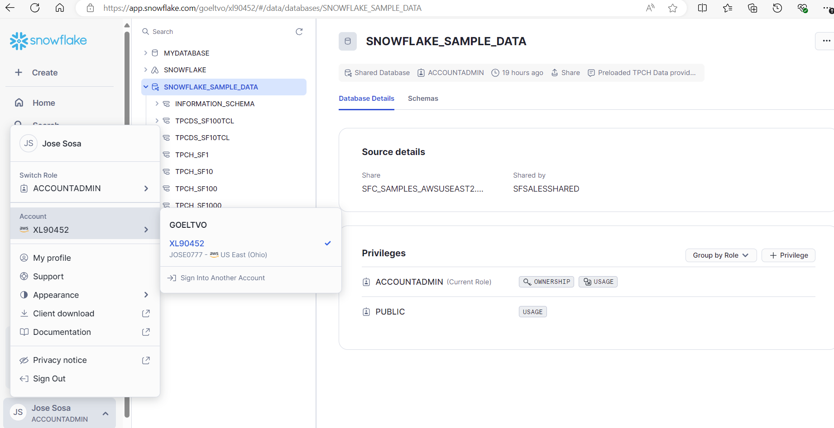

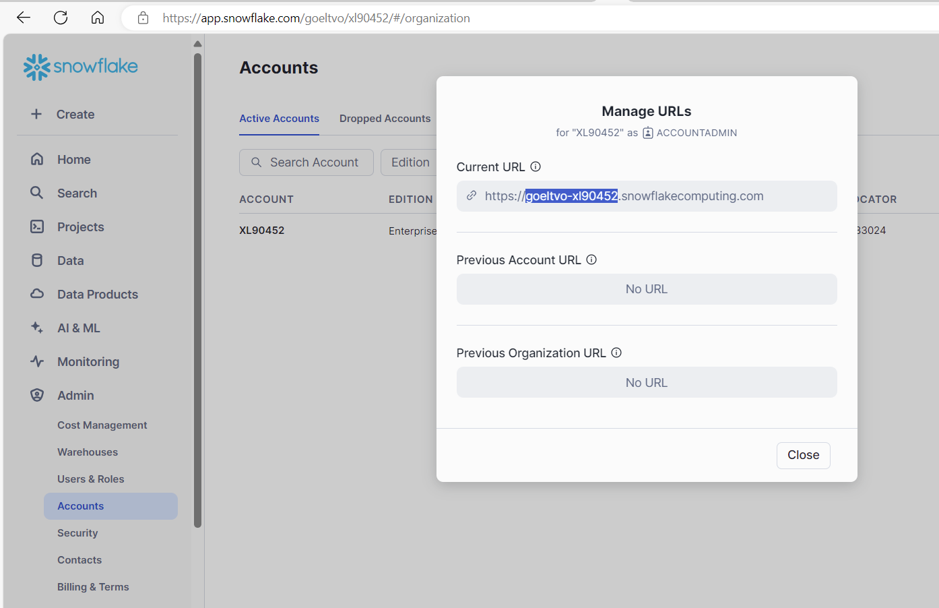

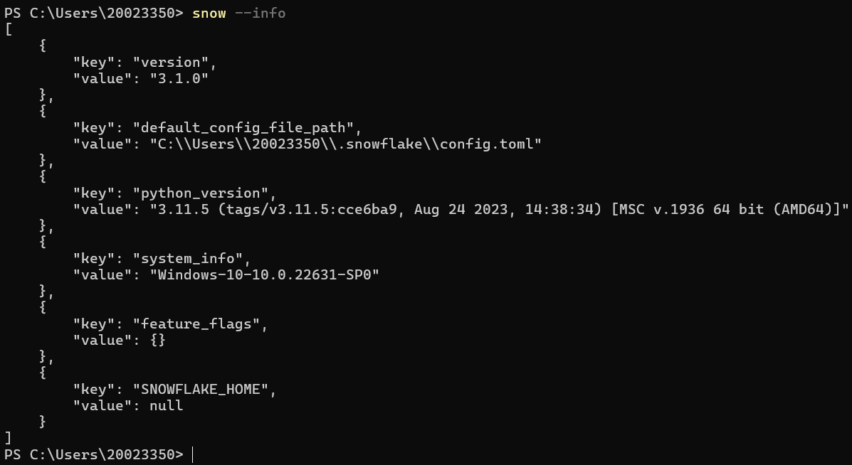

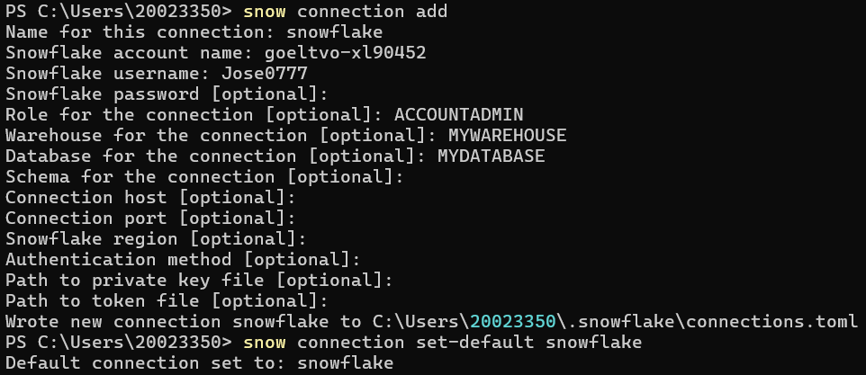

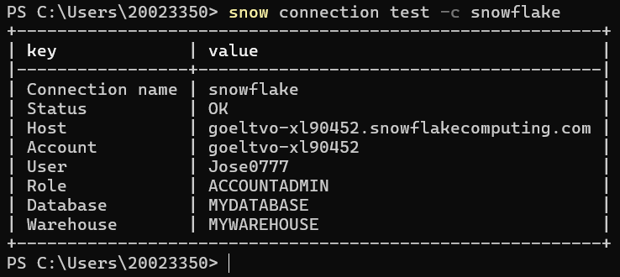

I can see the C:\Users\20023350\.snowflake\connections.toml:

[trial]

account = "goeltvo-xl90452"

user = "Jose0777"

password = "Jsl.0713"

database = "SNOWFLAKE_SAMPLE_DATA"

schema = "TPCH_SF10"

warehouse = "COMPUTE_WH"

role = "ACCOUNTADMIN"

[snowflake]

account = "goeltvo-xl90452"

user = "Jose0777"

password = "Jsl.0713"

database = "MYDATABASE"

warehouse = "MYWAREHOUSE"

role = "ACCOUNTADMIN"

Nota: hay que agregar el schema

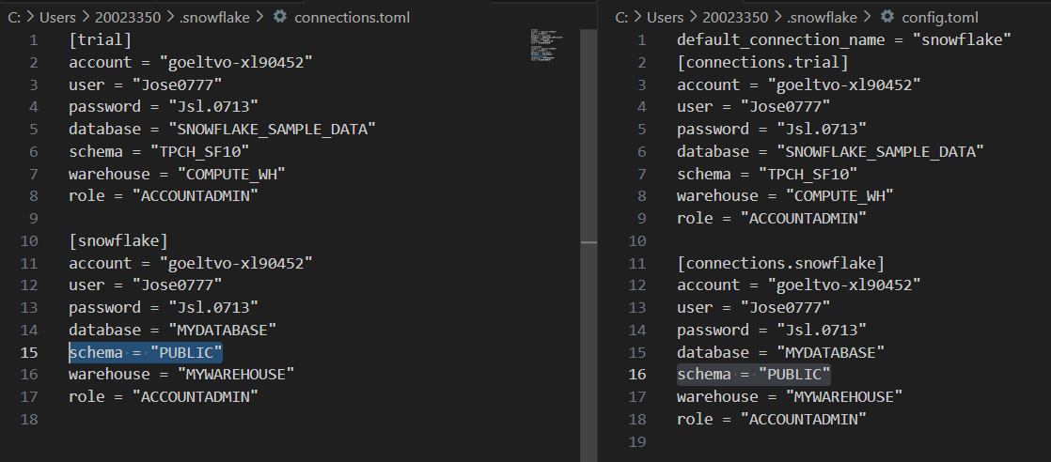

Ejecuto nuevamente:

PUT file://C:\Users\20023350\Documents\snowflake\data-load-internal\contacts*.csv @my_csv_stage AUTO_COMPRESS=TRUE;

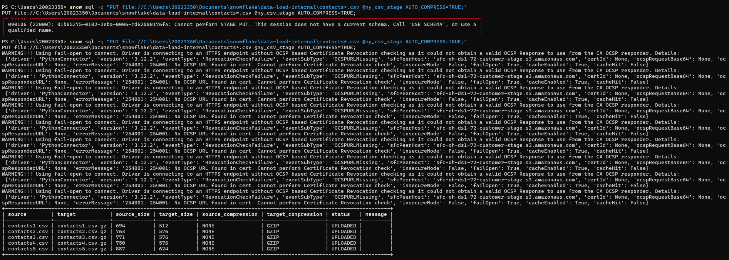

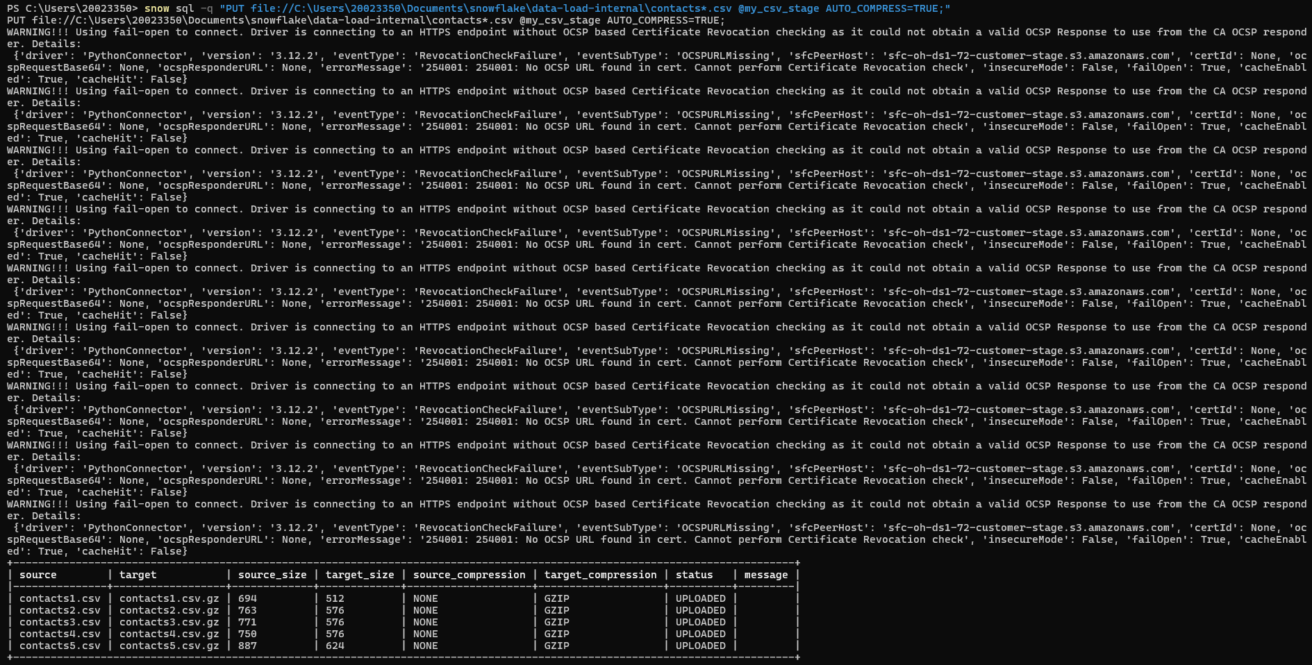

**Almacenamiento provisional de los archivos de datos de ejemplo JSON**

PUT file://C:\Users\20023350\Documents\snowflake\data-load-internal\contacts.json @my_json_stage AUTO_COMPRESS=TRUE;

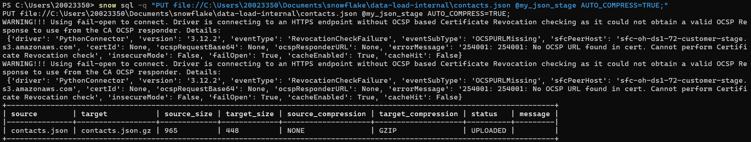

Puede enumerar los archivos almacenados provisionalmente mediante el comando LIST.

LIST @my_csv_stage;

LIST @my_json_stage;

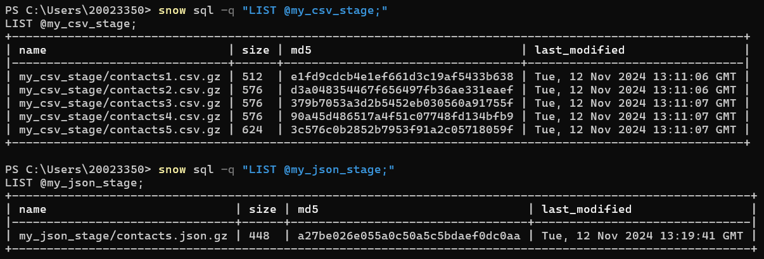

**Copiar datos en las tablas de destino**

Ejecute COPY INTO <table> para cargar los datos almacenados provisionalmente en las tablas de destino.  
  
Nota que previamente se creó la tabla ***temporal***, si no existe crearla.

Example for a specific file:  
COPY INTO mycsvtable

FROM @my_csv_stage/contacts1.csv.gz

FILE_FORMAT = (FORMAT_NAME = mycsvformat)

ON_ERROR = 'skip_file';

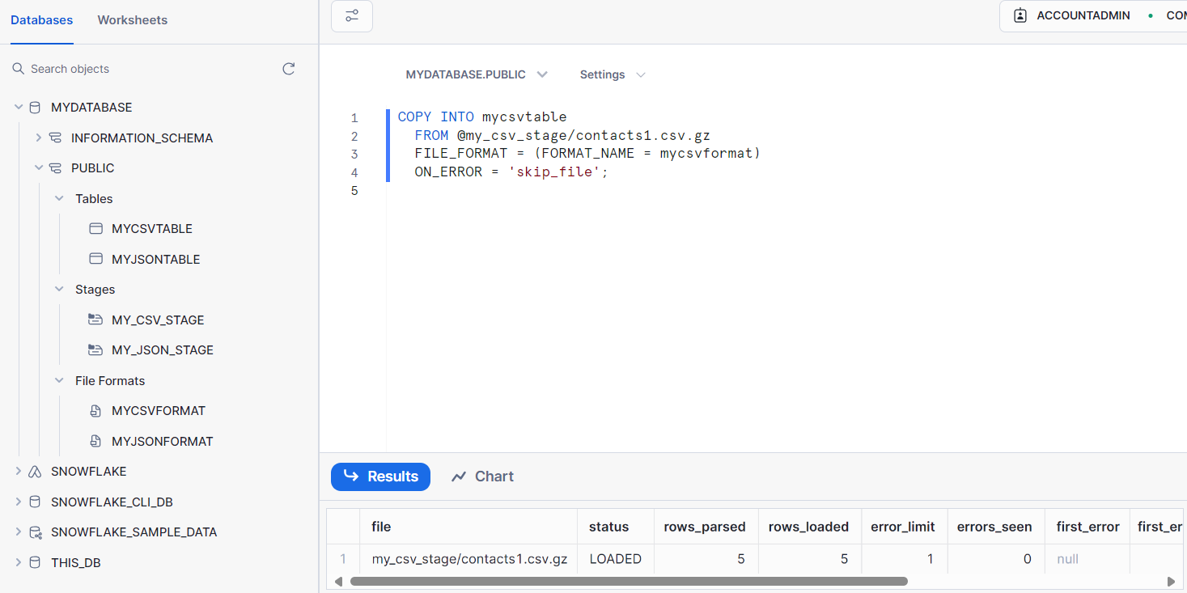

Using a pattern:  
COPY INTO mycsvtable

FROM @my_csv_stage

FILE_FORMAT = (FORMAT_NAME = mycsvformat)

PATTERN='.*contacts[1-5].csv.gz'

ON_ERROR = 'skip_file';

Execute a SELECT query to verify that the data was loaded successfully.

SELECT * FROM mycsvtable;

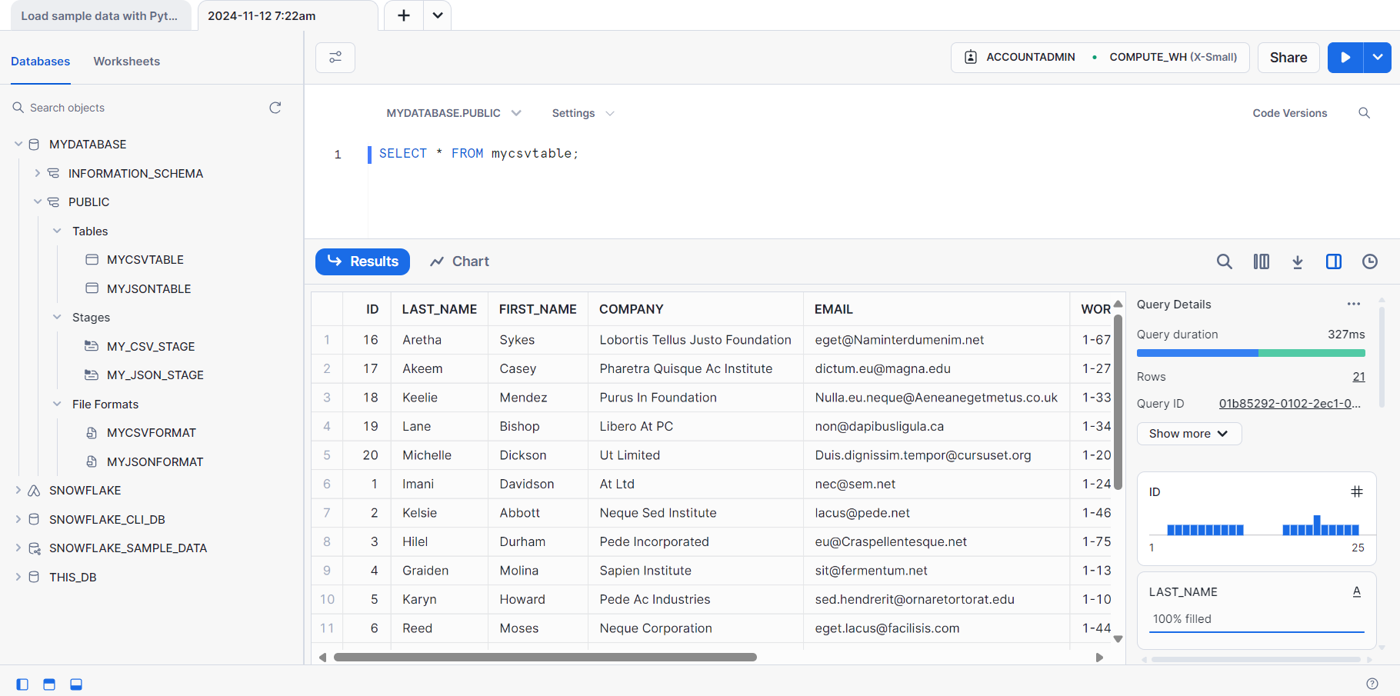

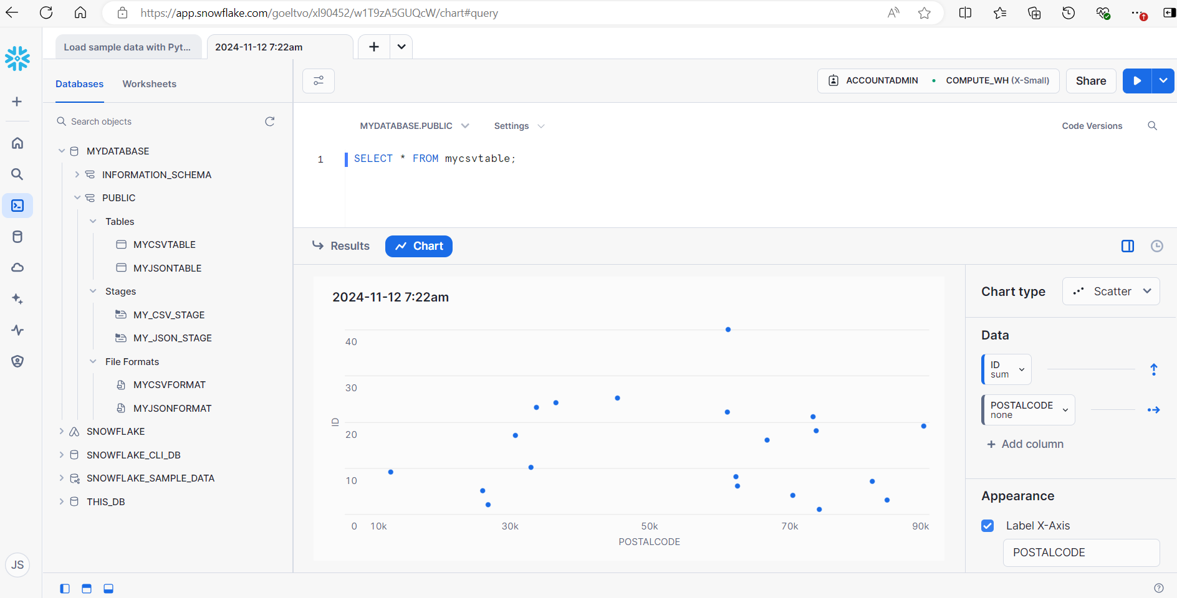

Load the staged data file into the table.contacts.json.gz myjsontable

COPY INTO myjsontable

FROM @my_json_stage/contacts.json.gz

FILE_FORMAT = (FORMAT_NAME = myjsonformat)

ON_ERROR = 'skip_file';

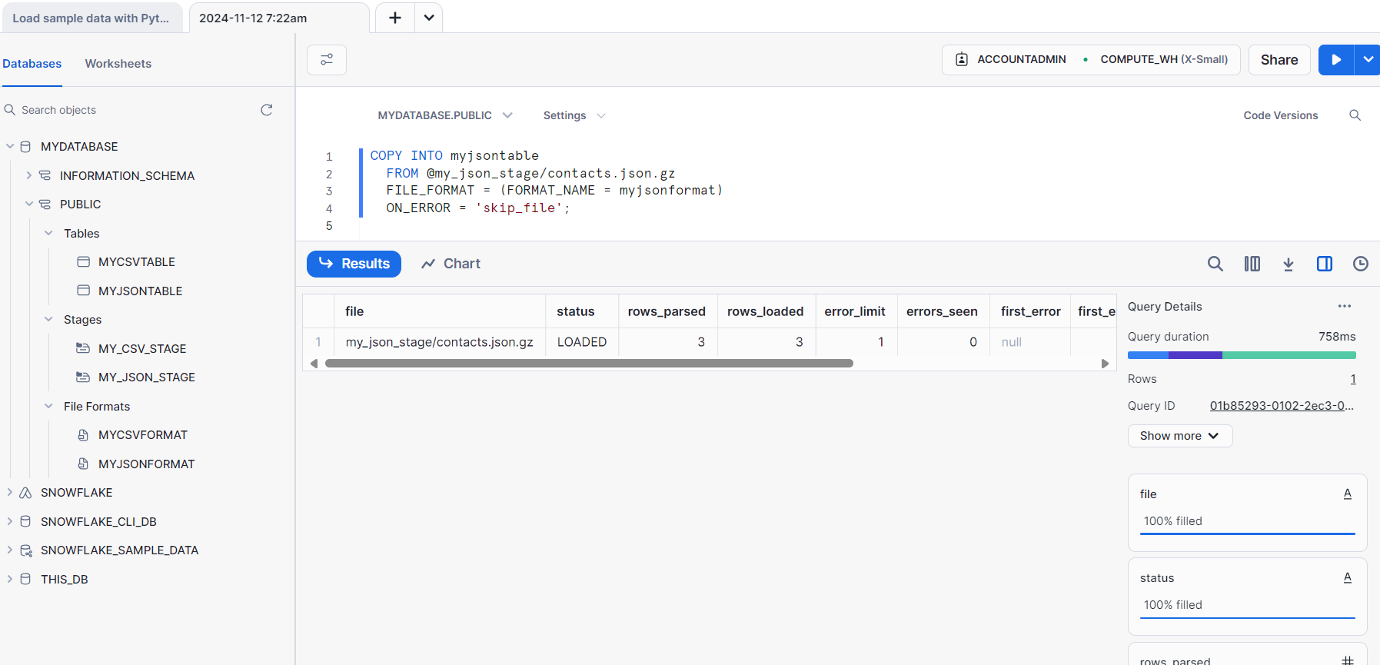

**Remove the successfully copied data files**

REMOVE @my_csv_stage PATTERN='.*.csv.gz';

REMOVE @my_json_stage PATTERN='.*.json.gz';

**Clean up**

DROP DATABASE IF EXISTS mydatabase;

DROP WAREHOUSE IF EXISTS mywarehouse;

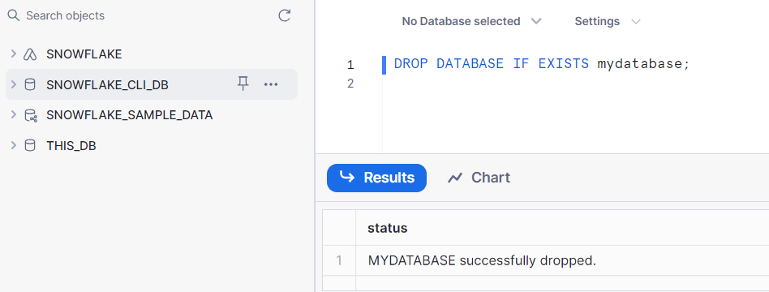

# **Tutorial 2, SnowSQL**

[Snowflake in 20 minutes | Snowflake Documentation](https://docs.snowflake.com/user-guide/tutorials/snowflake-in-20minutes#log-in-to-snowsql)

Install it using the installer

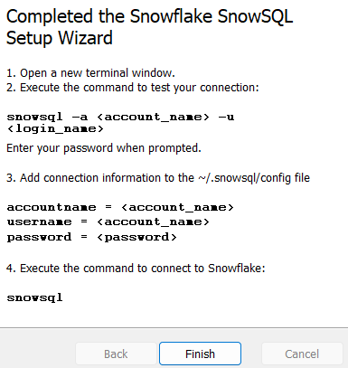

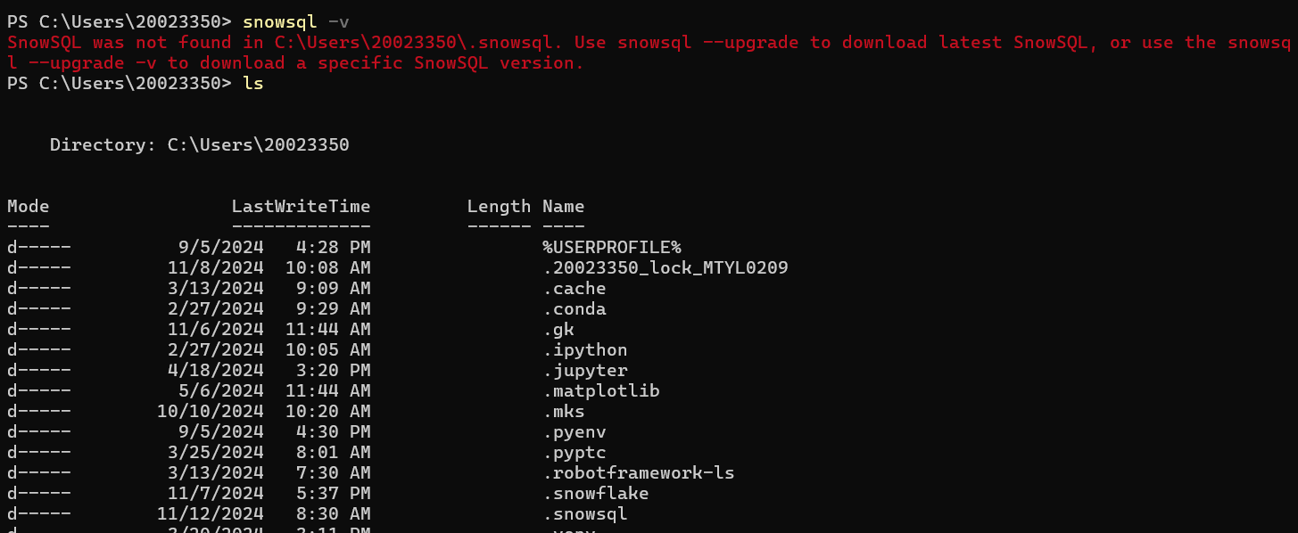

snowsql -v

to enable auto-upgrade during that specific session. For example:

snowsql -o noup=False

**Login to SnowSQL**

$ snowsql -a <account_identifier> -u <user_name>

snowsql -a goeltvo-xl90452 -u Jose0777 --authenticator externalbrowser

$ snowsql -a <account_identifier> -u <user_name> --authenticator externalbrowser

# **Tutorial 3, Tutorial: Bulk loading from Amazon S3 using COPY**

[Tutorial: Bulk loading from Amazon S3 using COPY | Snowflake Documentation](https://docs.snowflake.com/user-guide/tutorials/data-load-external-tutorial#introduction)

### Prerequisites:

You have a Snowflake account that is configured to use Amazon Web Services (AWS) and a user with a role that grants the necessary privileges to create a database, tables, and virtual warehouse objects.

You have SnowSQL installed.

### Create file format objects

CREATE OR REPLACE FILE FORMAT mycsvformat

TYPE = 'CSV'

FIELD_DELIMITER = '|'

SKIP_HEADER = 1;

CREATE OR REPLACE FILE FORMAT myjsonformat

TYPE = 'JSON'

STRIP_OUTER_ARRAY = TRUE;

### Create stage objects

CREATE OR REPLACE STAGE my_csv_stage

FILE_FORMAT = mycsvformat

URL = 's3://snowflake-docs';

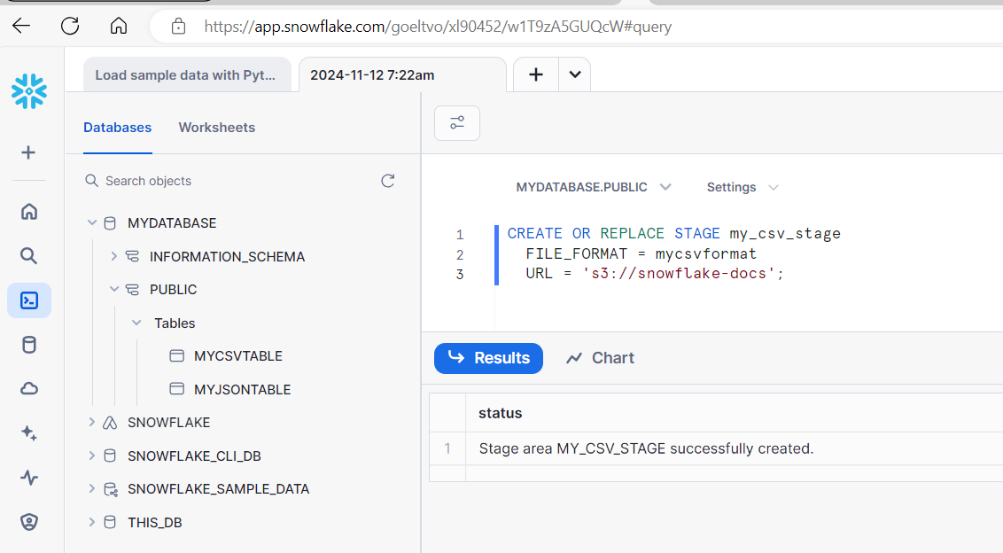

CREATE OR REPLACE STAGE my_json_stage

FILE_FORMAT = myjsonformat

URL = 's3://snowflake-docs';

### Copy data into the target table

COPY INTO mycsvtable

FROM @my_csv_stage/tutorials/dataloading/contacts1.csv

ON_ERROR = 'skip_file';

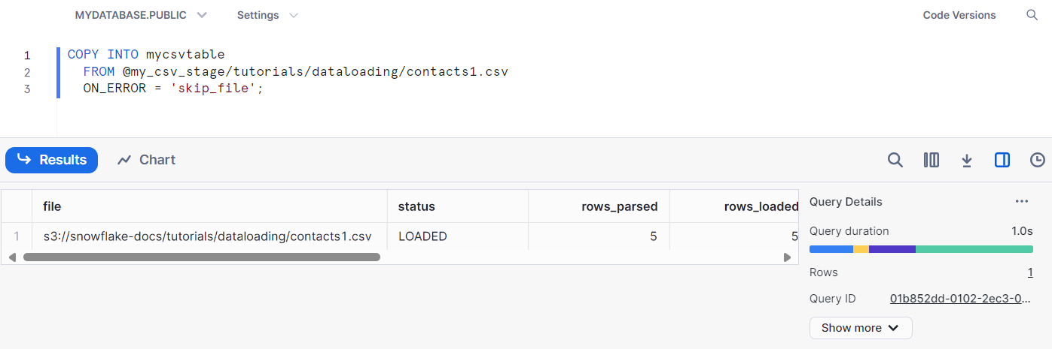

COPY INTO mycsvtable

FROM @my_csv_stage/tutorials/dataloading/

PATTERN='.*contacts[1-5].csv'

ON_ERROR = 'skip_file';

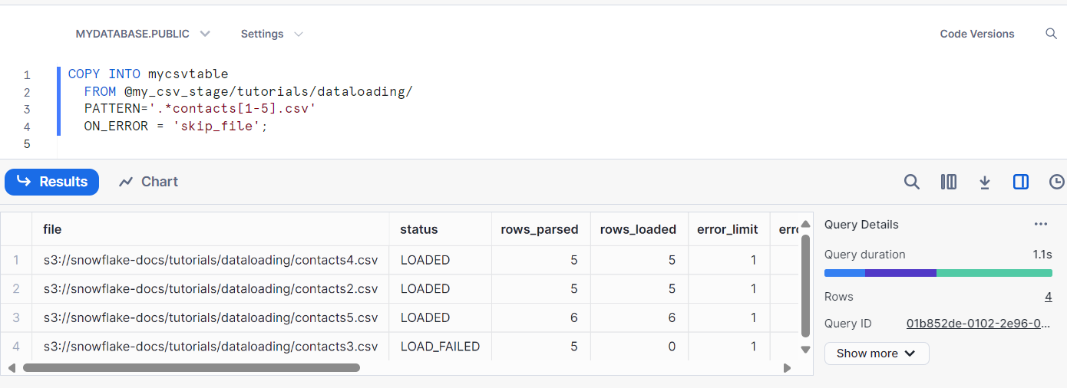

COPY INTO myjsontable

FROM @my_json_stage/tutorials/dataloading/contacts.json

ON_ERROR = 'skip_file';

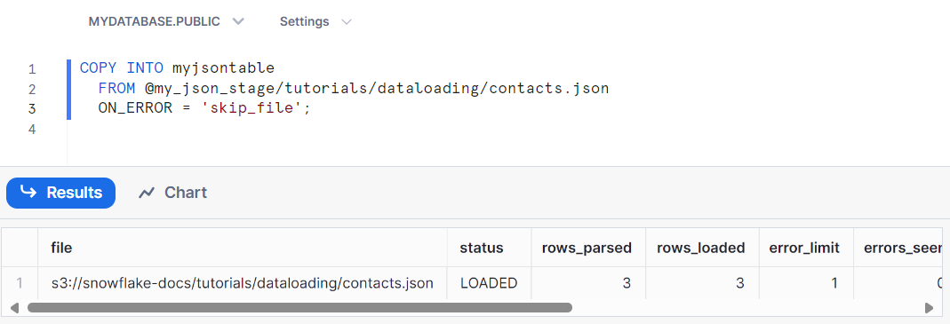

### Resolve data load errors related to data issues

In the preceding step, the COPY INTO command skipped loading one of the files when it encountered the first error. You need to find all the errors. In this step, you use the VALIDATE function to validate the previous execution of the COPY INTO command and return all errors.

1. Retrieve the query ID.
   1. Sign in to Snowsight.
   2. Make sure the role in Snowsight is the same as the role you are using in SnowSQL to run SQL statements for this tutorial.
   3. Select Monitoring » Query History.
   4. Select the row for the specific COPY INTO command to open the query information pane.
   5. Copy the Query ID value.

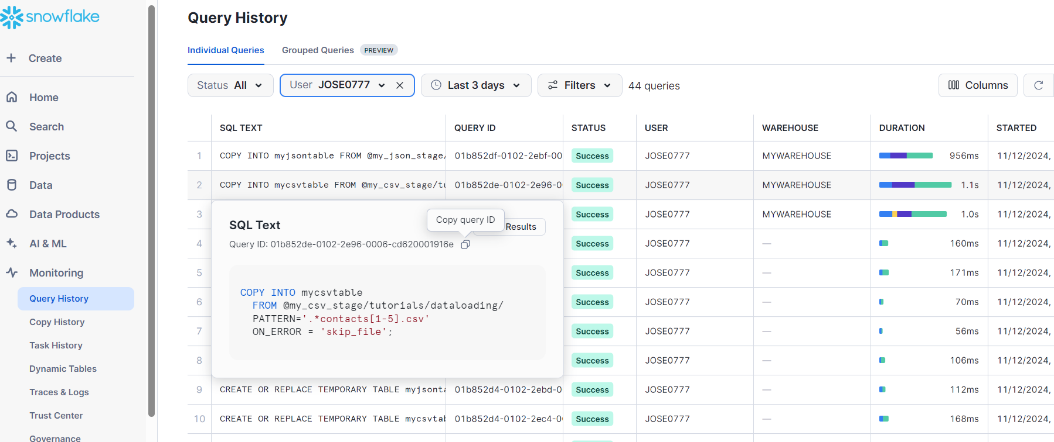

El query ID value fue: 01b852de-0102-2e96-0006-cd620001916e

1. Validate the COPY INTO command execution, represented by the query ID, and save errors to a new table named save_copy_errors.

\\elysdas\Eng_Data\09_Projects\Fusion_3.1\CY24-CW27_POLLUX_RC1_FC241853_FU241850\2024-07-31 POLLUX_RC1__Black_LT_026_AEB_SVB\Data\yaca_results

4535193 - 2024-07-31_11-31-39_2024-07-25 POLLUX_RC1__Black_LT_026_AEB_010

4535275 - 2024-07-31_14-30-54_2024-07-25 POLLUX_RC1__Black_LT_026_AEB_045

\\elysdas\Eng_Data\09_Projects\Fusion_3.1\CY24-CW27_POLLUX_RC1_FC241853_FU241850\2024-08-01 POLLUX_RC1__Black_LT_026_PAEB_CRB\yaca_results

4535154 - 2024-08-01_14-09-59_2024-07-25 POLLUX_RC1__Black_LT_026_PAEB_CRB_145(100_percent_speed_reduction_expected).csv

4535154 - 2024-08-01_10-40-07_2024-07-25 POLLUX_RC1__Black_LT_026_PAEB_CRB_111(100_percent_speed_reduction_expected).png

4535257 - 2024-08-01_09-55-43_2024-07-25 POLLUX_RC1__Black_LT_026_PAEB_CRB_104(vego_set=60 mph, vtarget=57 mph).csv

4535257 - 2024-08-01_09-55-43_2024-07-25 POLLUX_RC1__Black_LT_026_PAEB_CRB_104(vego_set=60 mph, vtarget=57 mph).png

4535193 - 2024-08-01_14-28-04_2024-07-25 POLLUX_RC1__Black_LT_026_PAEB_CRB_147.csv

4535193 - 2024-08-01_14-37-09_2024-07-25 POLLUX_RC1__Black_LT_026_PAEB_CRB_149.png

\\elysdas\Eng_Data\09_Projects\Fusion_3.1\CY24-CW27_POLLUX_RC1_FC241853_FU241850\2024-08-13_POLLUX_RC1__Red_PB_694_AEB_CRB_PAEB\yaca_results

1111113 - 2024-08-13_10-00-06_POLLUX_RC1__Red_PB_694_AEB_002.csv

1111113 - 2024-08-13_10-00-06_POLLUX_RC1__Red_PB_694_AEB_002.png

\\elysdas\Eng_Data\09_Projects\Fusion_3.1\CY24-CW27_POLLUX_RC1_FC241853_FU241850\2024-08-14_POLLUX_RC1_Red_PB_694_AEB_CRB\2024-08-14_POLLUX_RC1__Red_PB_694_AEB_CRB\yaca_results

4535275 - 2024-08-14_13-41-05_POLLUX_RC1__Red_PB_694_AEB_017.csv

4535275 - 2024-08-14_13-41-05_POLLUX_RC1__Red_PB_694_AEB_017.png

4535257 - 2024-08-14_11-15-28_POLLUX_RC1__Red_PB_694_AEB_006(vego_set=40 mph, vtarget=37 mph).csv

4535257 - 2024-08-14_11-15-28_POLLUX_RC1__Red_PB_694_AEB_006(vego_set=40 mph, vtarget=37 mph).png

2024-08-13_10-03-48_POLLUX_RC1__Red_PB_694_AEB_003

2023-05-25_10-40-01_ASTERIA_RC1_Black-LT-026_113

**Snowpipe**

<https://docs.snowflake.com/user-guide/data-load-snowpipe-intro>

Snowpipe enables loading data from files as soon as they’re available in a stage. This means you can load data from files in micro-batches, making it available to users within minutes, rather than manually executing COPY statements on a schedule to load larger batches.

**Use SnowflakeDB for SQL queries**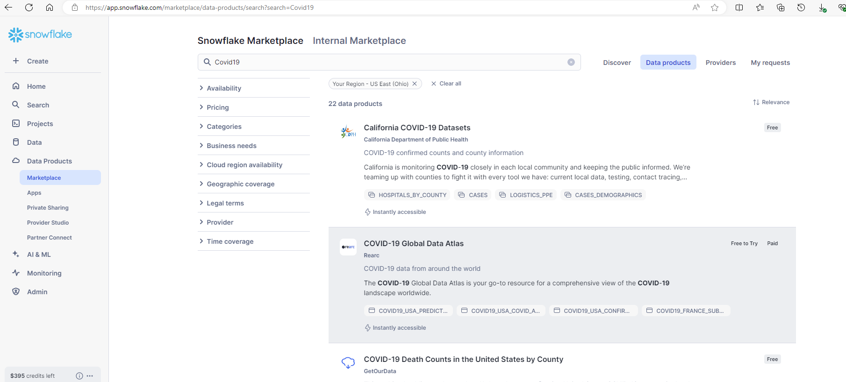

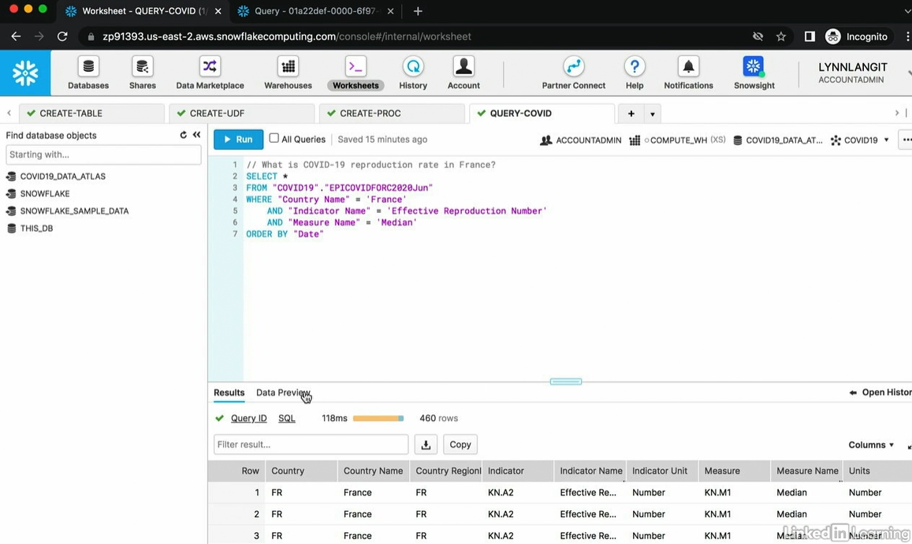

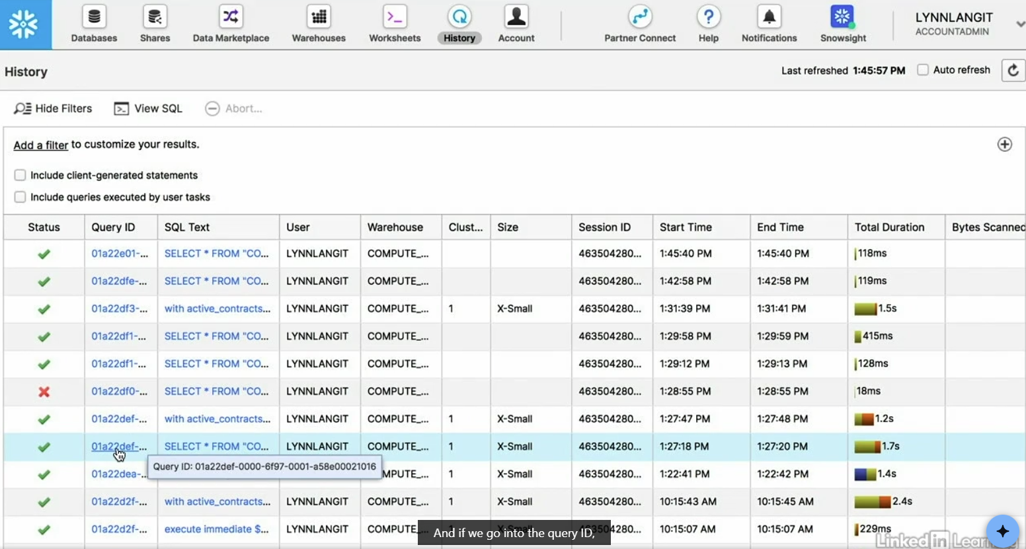

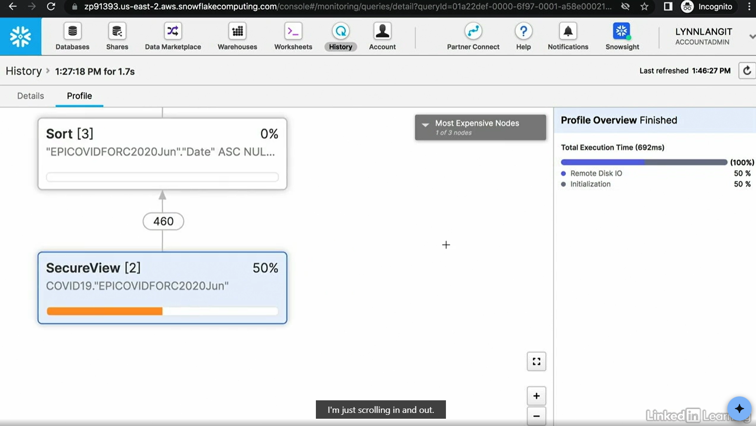

**Understand SnowflakeDB dashboards**

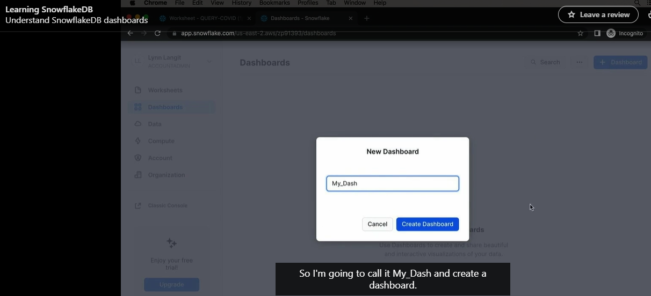

Run the query:  
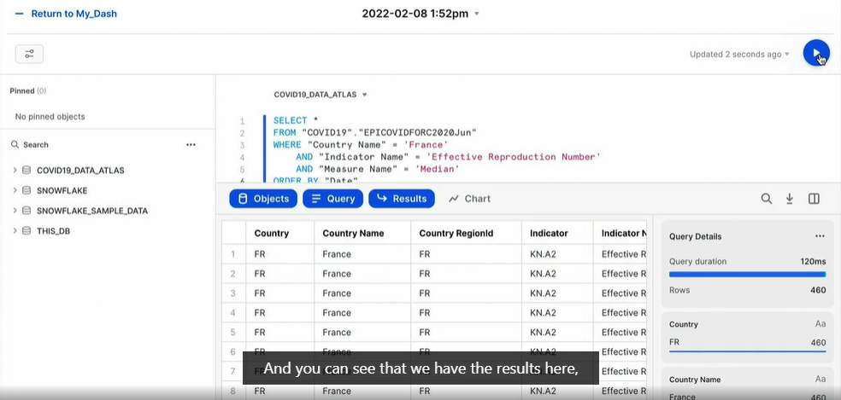

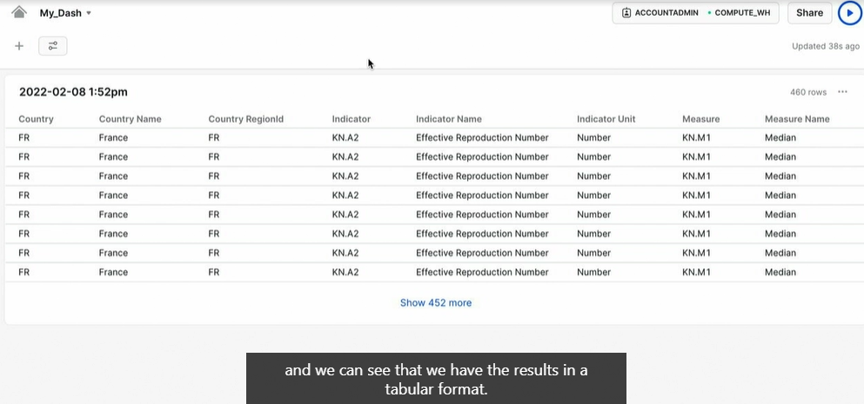

We can also add a new tile in the dashboard:  
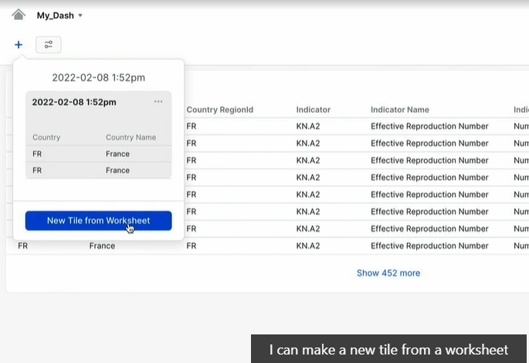

And after run the query set the view, as the scorecard for example: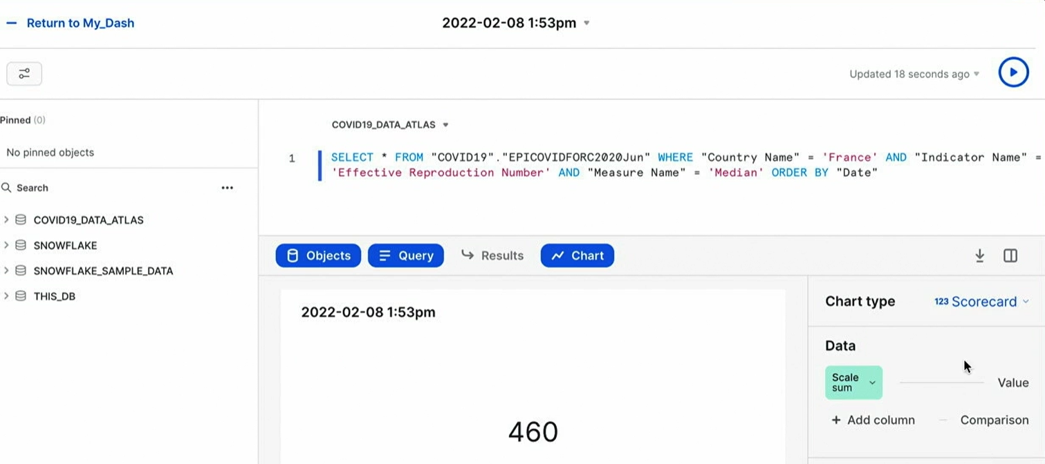

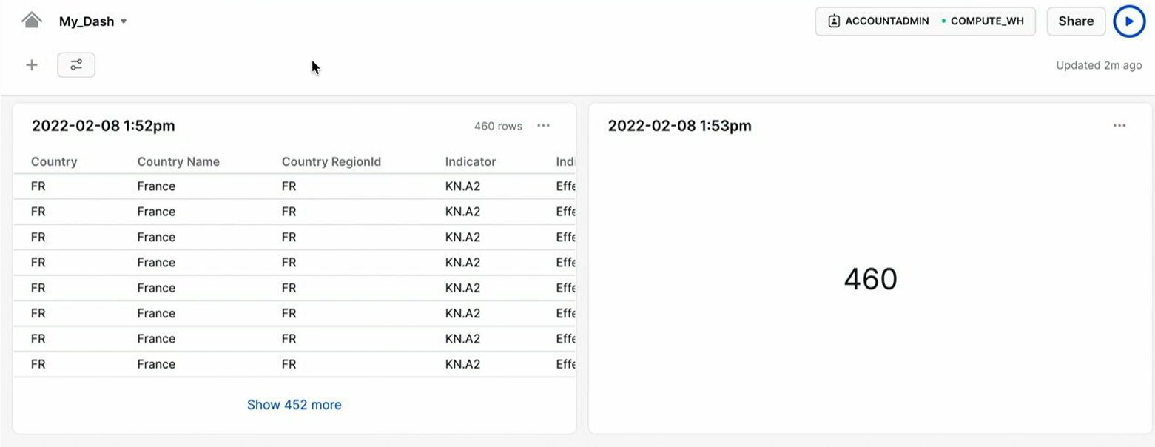

**Create and use user-defined functions (UDF) or user defined table function (UDTF)**

[User-defined functions overview | Snowflake Documentation](https://docs.snowflake.com/developer-guide/udf/udf-overview)

Go to Worksheets and create a new:  
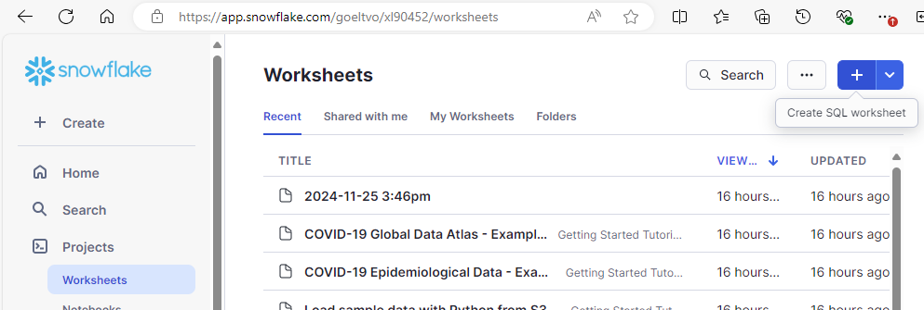

Example:  
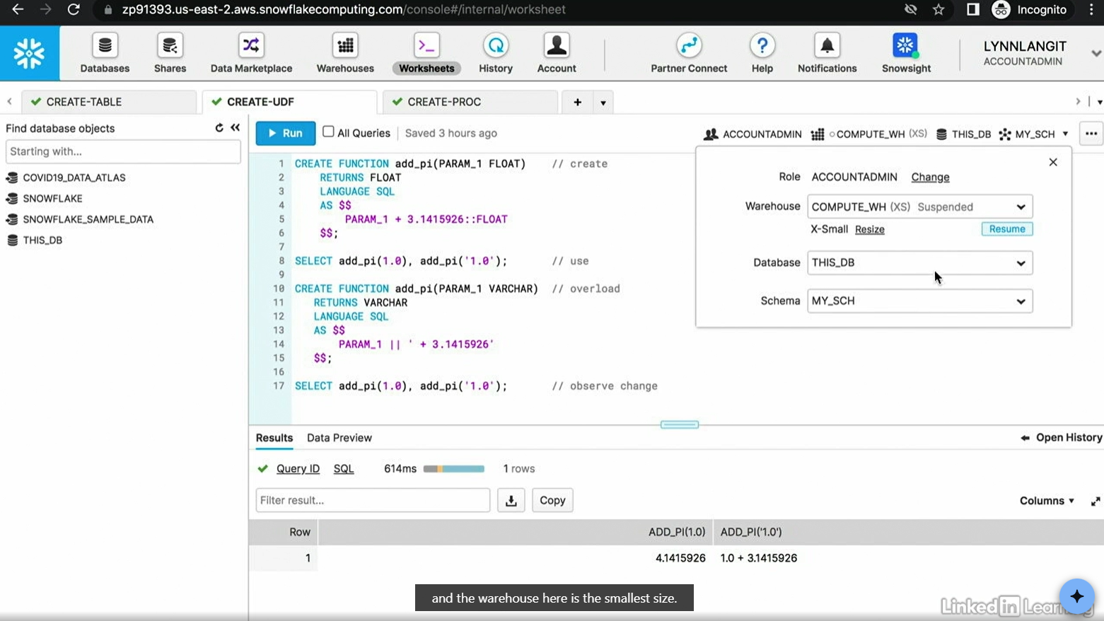

CREATE FUNCTION add_pi(PARAM_1 FLOAT)  // create

    RETURNS FLOAT

    LANGUAGE SQL

    AS $$

        PARAM_1 + 3.1415926::FLOAT

    $$;

SELECT add_pi(1.0), add_pi('1.0');  // use

CREATE FUNCTION add_pi(PARAM_1 VARCHAR)  // overload

    RETURNS VARCHAR

    LANGUAGE SQL

    AS $$

        PARAM_1 || '+ 3.1415926'

    $$;

SELECT add_pi(1.0), add_pi('1.0');  // observe change

Note: Select all lines that you want to run to execute it.

// Working with Python Language

CREATE OR REPLACE FUNCTION addone(i int, msg string)

RETURNS STRING

LANGUAGE PYTHON

RUNTIME_VERSION = '3.9'

HANDLER = 'addone_py'

as

$$

def addone_py(i, msg):

  return f"{msg} {i}+1"

$$;

SELECT addone(3, 'message: ')

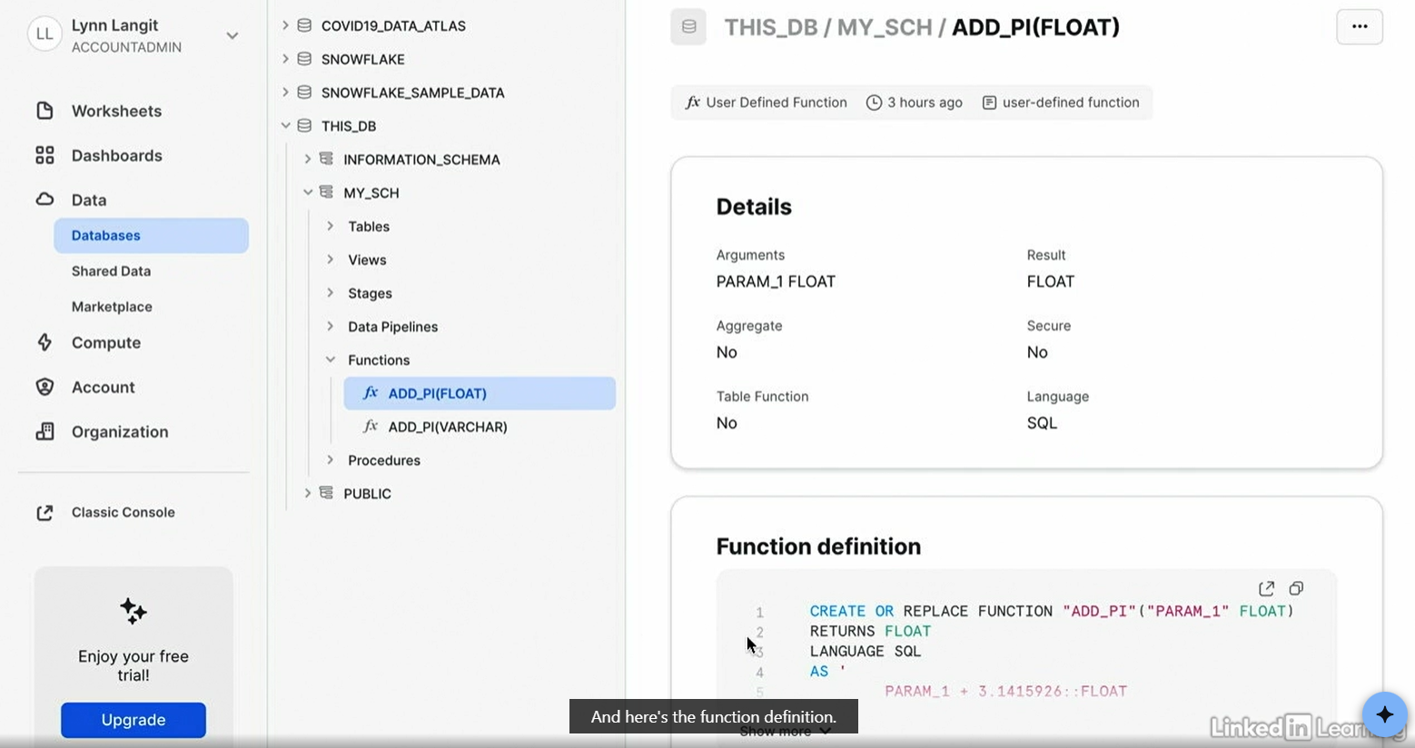

Other example without procedure because it is running inmediately:  
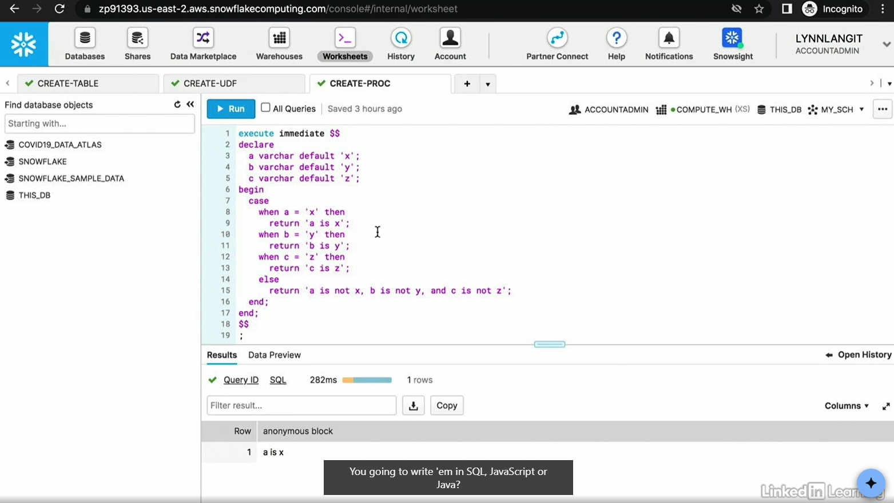 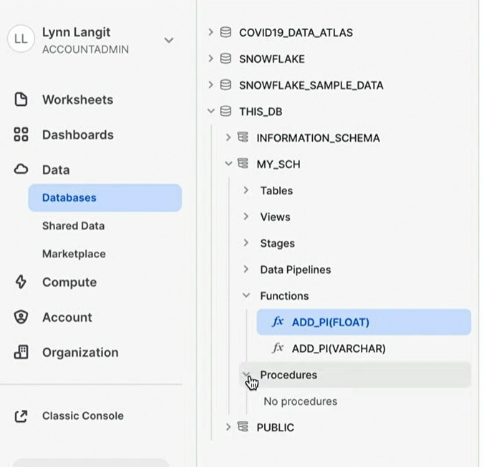

execute immediate $$

declare

    a varchar default 'x';

    b varchar default 'y';

    c varchar default 'z';

begin

    case

        when a = 'x' then

            return 'a is x';

        when b = 'y' then

            return 'b is y';

        when c = 'z' then

            return 'c is z';

        else

            return 'a is not x, bis not y, and c is not z';

    end;

end;

$$

;

# **Optimize Warehouses**

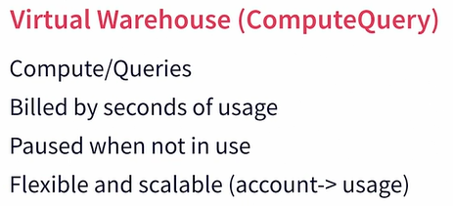

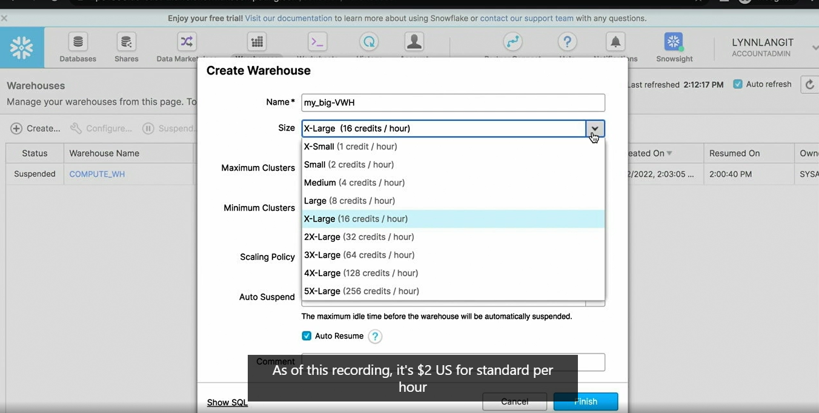

The scaling policy is about how quickly you are going to scale

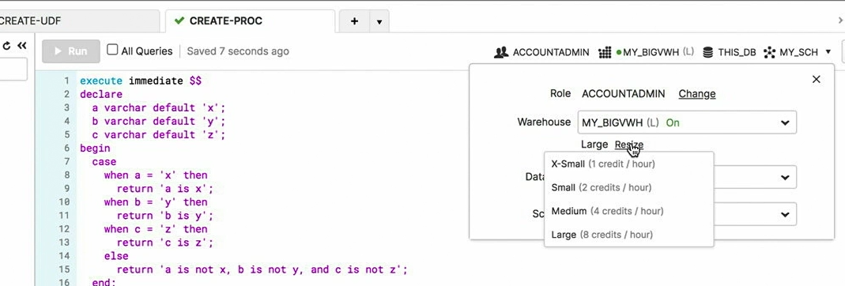

Queued load is important to not have a lot.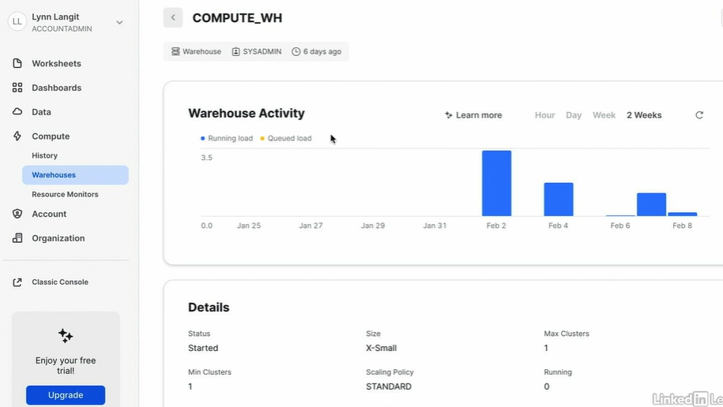

# Optimize SnowflakeDB compute

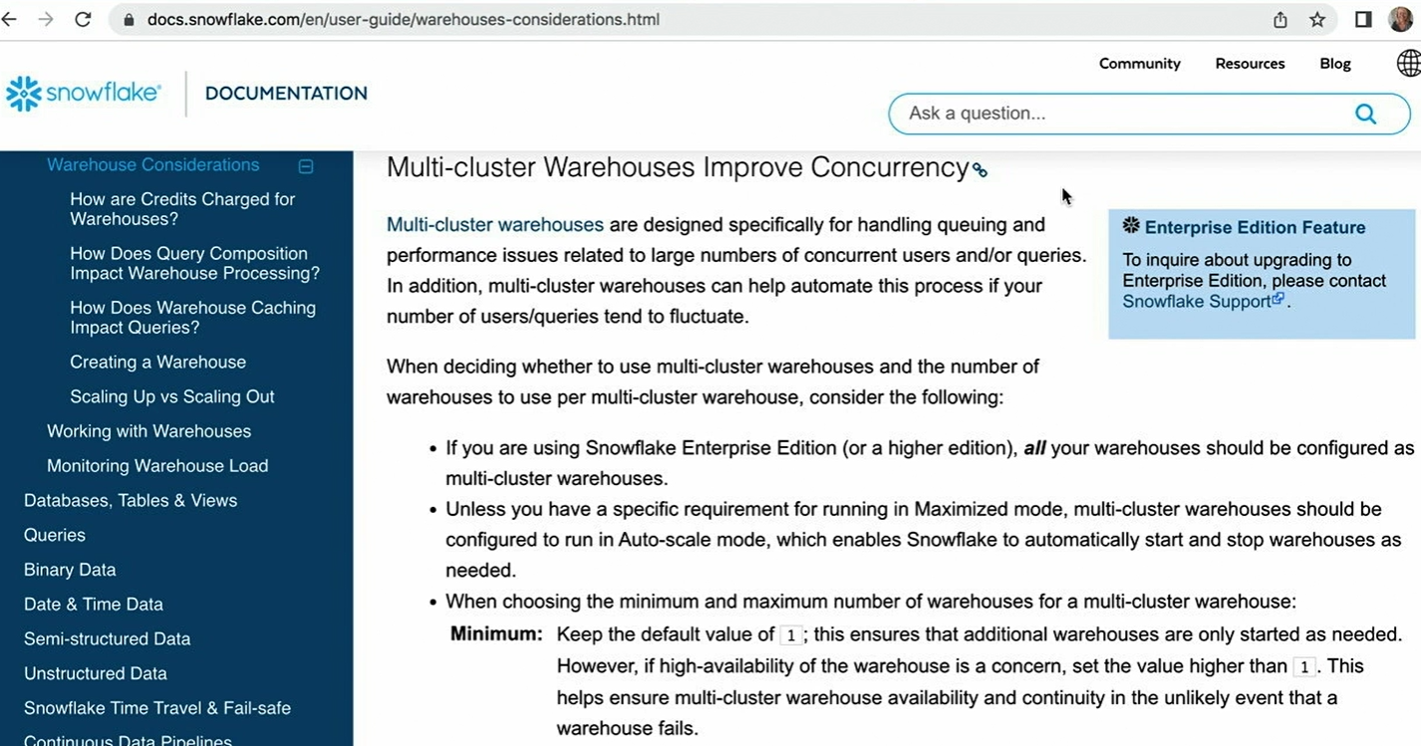

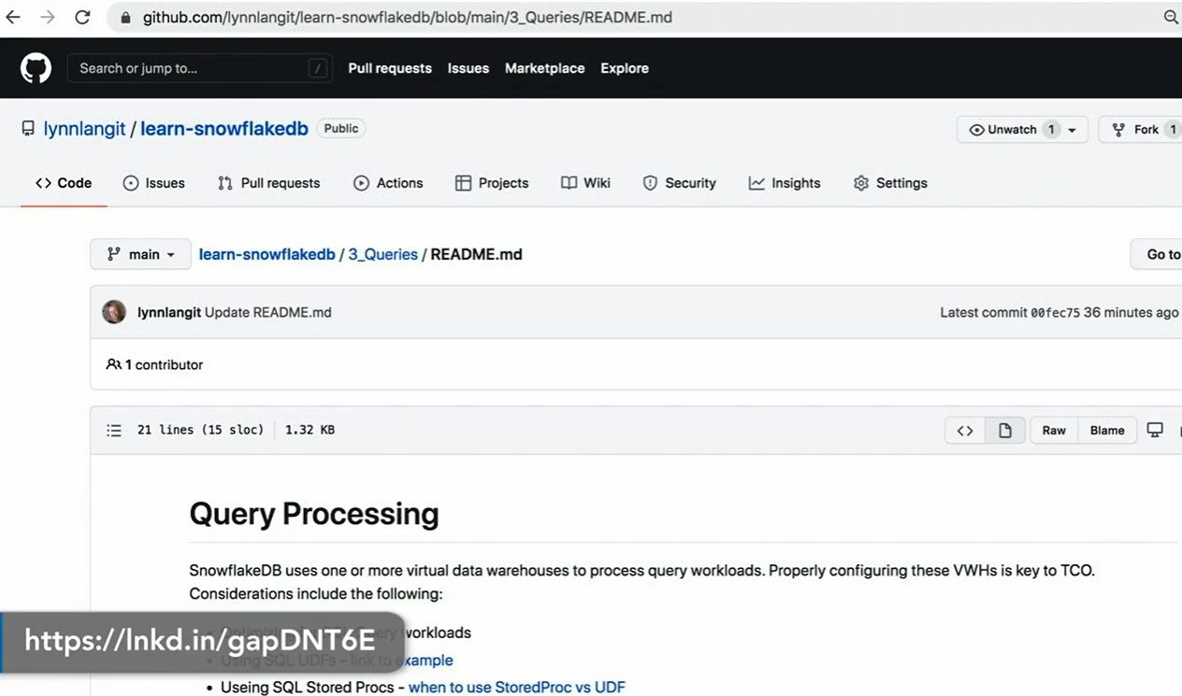

[GitHub - lynnlangit/learn-snowflakedb: Resources to work with SnowflakeDB](https://github.com/lynnlangit/learn-snowflakedb)

<https://youtu.be/AR88dZG-hwo?si=aQGIbAL5YUgSdRvn>

In the query view, you can quickly verify whether the auto-caching optimization technique has been used for your query.

The smallest possible virtual warehouse uses 1 credit(s) per hour.

SnowflakeDB dashboards are composed of items called tiles

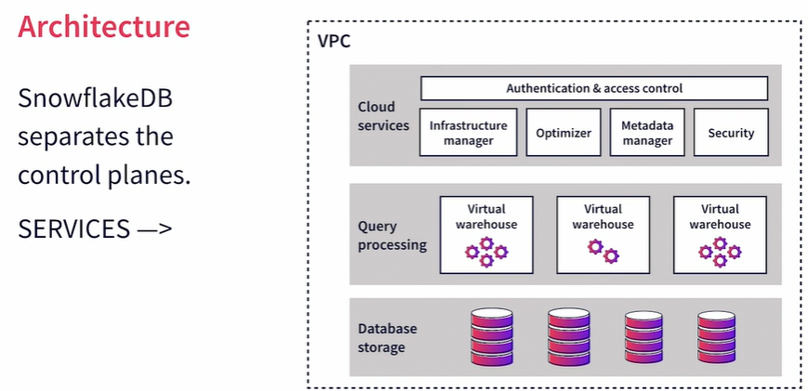

# Users & Roles

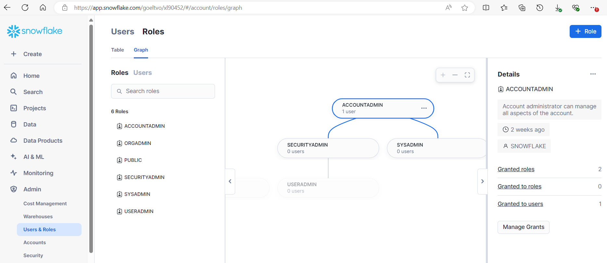

It’s possible also to create a reader account:  
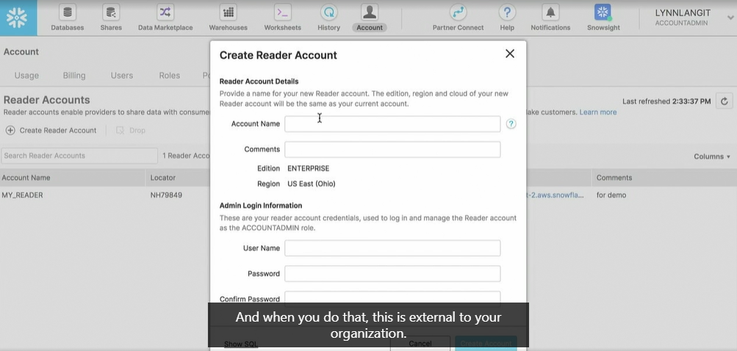

# Review Sessions & Authentication

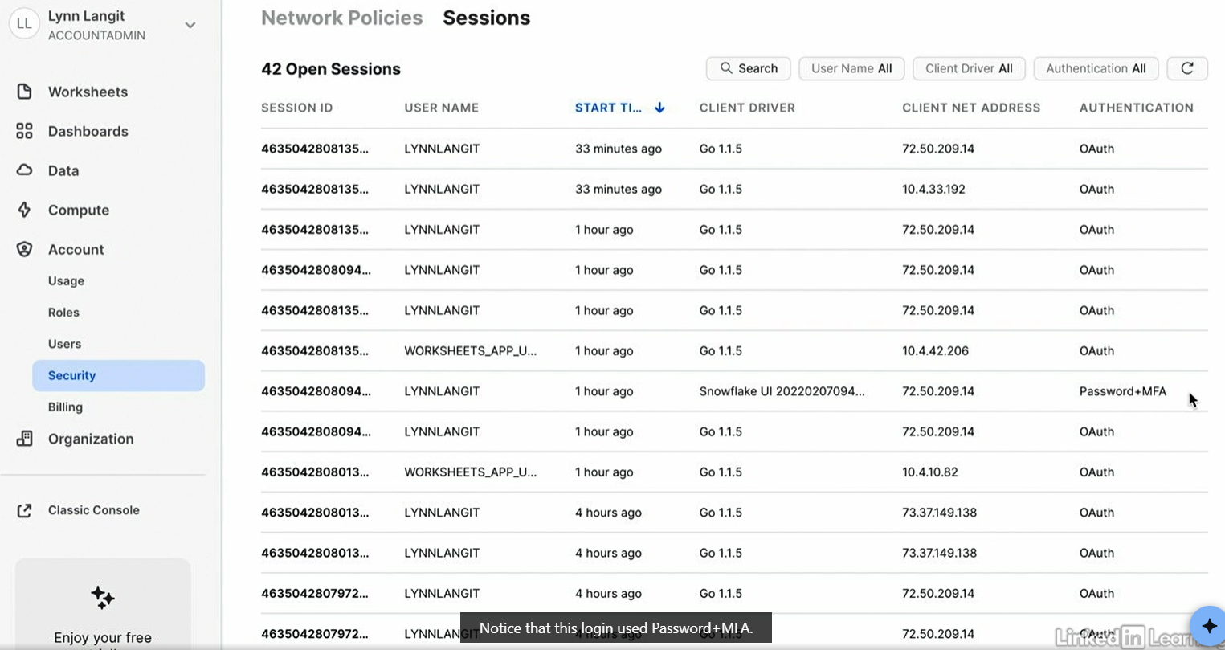

# Implement Policies

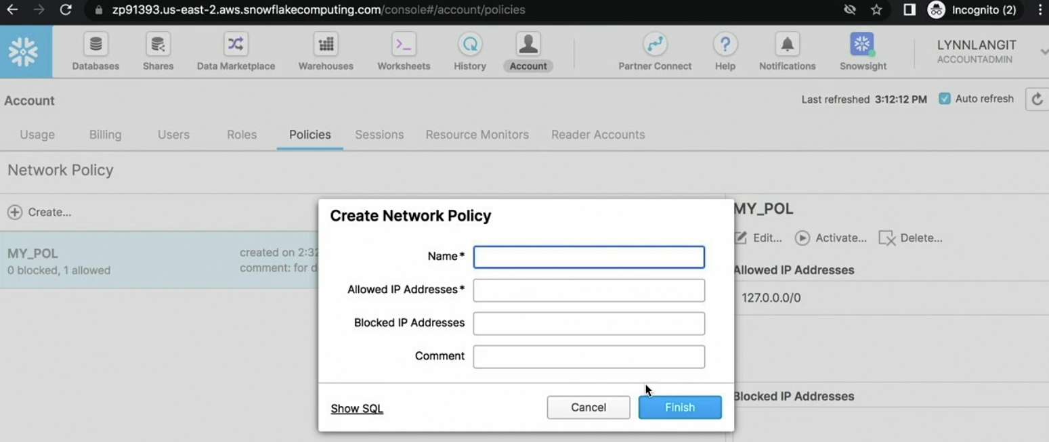

Its required to activate it

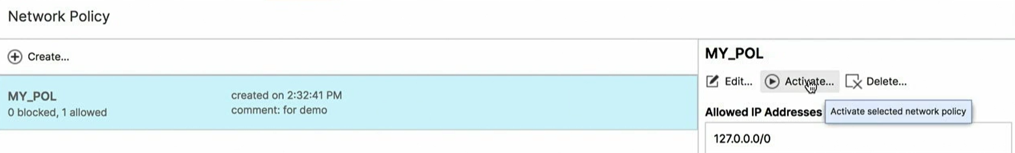

SnowflakeDB policies restrict access based on IP address

What must you do to run a policy? Activate it

Which SnowflakeDB feature assigns permissions? Roles

Where can you view SnowflakeDB sessions? Both the classic console and Snowsight console

SnowflakeDB usage is billed and measured in credits

Snowflake data life cycle

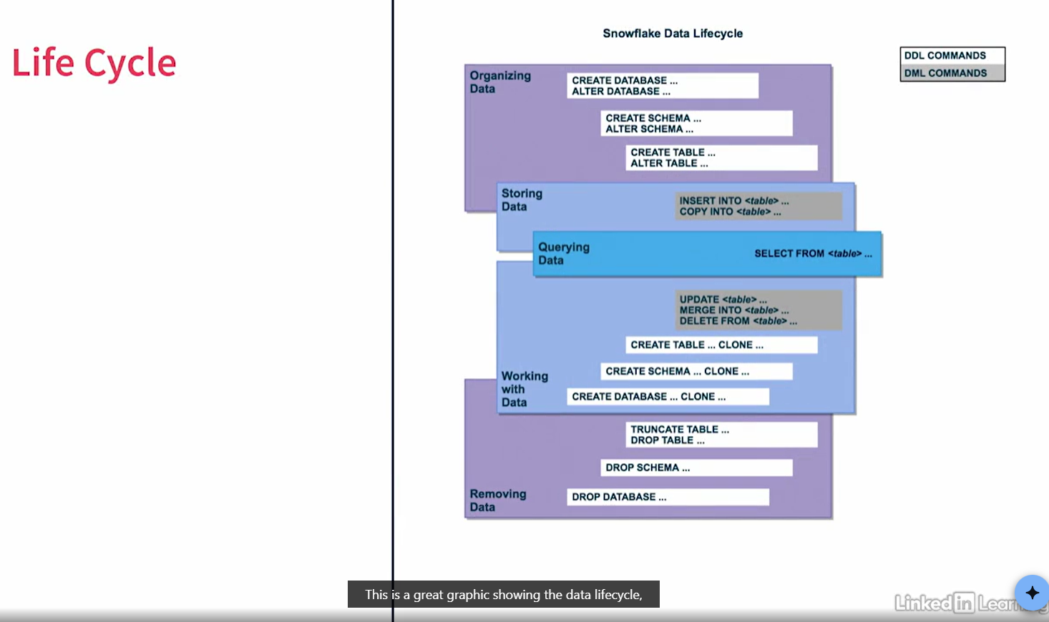

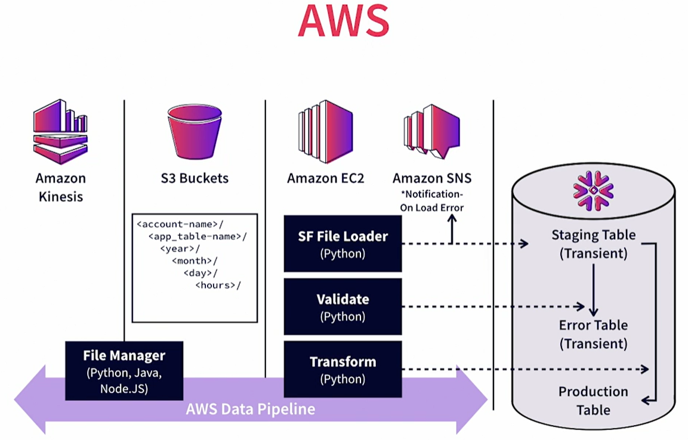

Transient vs temporary:

Temporary is persistent for the session, and transient is until dropped.

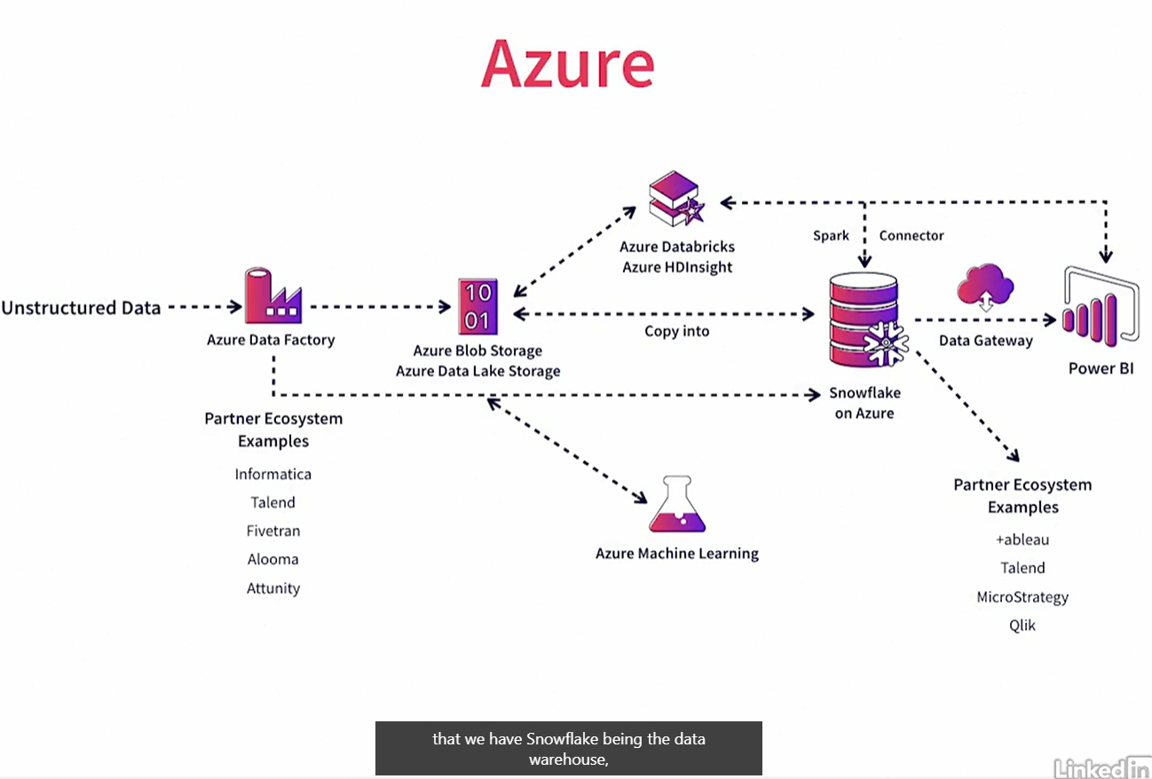

[Snowflake Resources Library](https://www.snowflake.com/en/resources/)

Typically, what are stage objects in SnowflakeDB pipelines? Buckets

To find information about architectural structures for workflows, where should you go on the SnowflakeDB resources website? the Patterns library

In the data marketplace, which type of data must you purchase? Premium

In which Snowflake console(s) can you find Partner Connect? Classic console

